CSS GENDER STUDIES
T6KB
The Knowledge Base
Topic 6 · Gender and Governance — voters, candidates, representatives and quotas, taught from zero
WHAT THIS DOCUMENT GIVES YOU
◆ Syllabus Head VII taught from zero in simple English — what governance is and why gender matters to it
◆ The suffrage movement in the West, the world and South Asia
◆ Women as voters, candidates and representatives in Pakistan, with the 2024 election data
◆ Gender quotas — types, arguments for and against, and the full history of Pakistan's reserved seats from 1956 to today
◆ Whether women representatives make a difference, and women in leadership — glass ceiling, glass cliff and "pulling each other up"
◆ Case studies of India, Bangladesh, Sri Lanka and Nepal
◆ Today's debates, the record and five likely questions
◆ About 120 MCQ-style one-liners, every past MCQ on the topic, and a detailed revision sheet
Federal Public Service Commission · CSS Competitive Examination · Optional paper, 100 marks
Written for CE-2027 onwards · Record: CE-2016 to CE-2026 · Facts current to September 2026

Contents
HOW TO BUILD THE CONTENTS
The contents list below fills itself in. When Word asks "This document contains fields that may refer to other files. Update the fields?", click Yes.
If it does not ask: right-click the grey contents area → Update Field → Update entire table → OK. On a Mac, Control-click the same area. Or press Ctrl + A, then F9 (Windows), to update every field at once. Repeat after any edit, before you export to PDF.

Right-click here and choose Update Field to build the contents.

How to Use This Document

What this topic covers
Topic 6 is syllabus Head VII — Gender and Governance. The syllabus names six lines: defining governance; the suffragist movement; gender issues in women as voters, as candidates and as representatives; the impact of women representatives on politics; and case studies of Sri Lanka, Pakistan, India, Bangladesh and Nepal. This document teaches all of them, and gives the most space to the line the examiner loves most: political quotas for women in Pakistan.
In the descriptive paper Topic 6 has had 8.5 visits: eight full questions and one short note. Quotas dominate — 2016, 2021, 2024 and 2025 all asked about them — and women's political participation follows (2017, 2018, 2024). Women as representatives (2022) and women in leadership (2020) complete the record. The topic also supplies 14 of the 140 MCQs, mostly firsts and numbers: the two women of the first Constituent Assembly, 60 reserved seats, 33% under devolution, Benazir Bhutto, Fahmida Mirza, New Zealand 1893.
IN SIMPLE WORDS
Governance is how a country is run — who makes decisions, how, and for whom. Gender and governance asks a simple question: are women present where decisions are made, and are their interests served by those decisions? In Pakistan, women can vote, stand and sit in parliament, but at every step — voting, contesting, representing, leading — they meet barriers men do not.

How this document is built
1. Part Zero gives you the words of the topic and the "ladder" of political participation.
2. Part One has ten chapters: governance and representation (1); the suffrage movement (2); women as voters (3), as candidates (4) and as representatives (5); gender quotas — types and arguments (6); the history of Pakistan's quota (7); the impact of women representatives (8); women in leadership (9); and the South Asian case studies (10).
3. Part Two sets out today's debates.
4. Part Three lists every past question, what the record shows, and five likely questions.
5. Part Four is a bank of about 120 one-liners, followed by every past MCQ on the topic.
6. Part Five is the revision sheet.

Part Zero — The ABC of Topic 6

0.1 The words of this topic
Table 1 · The key terms of Topic 6 (★ = you must be able to define it in one sentence).
Term | Simple meaning, with an example
Governance ★ | The way power is used to manage a country's affairs — by the state, and also by markets and civil society.
Good governance ★ | Governance that is participatory, accountable, transparent, responsive, effective, equitable and follows the rule of law.
Gender-responsive governance | Governance in which women take part in decisions and policies serve women's and men's needs fairly.
Suffrage ★ | The right to vote (MCQ 2019). "Women's suffrage" = women's right to vote.
Suffragist | A campaigner for votes for women, especially one using peaceful, lawful methods.
Suffragette | A militant British campaigner for women's votes (the WSPU, from 1903).
Universal adult franchise | Every adult citizen may vote, regardless of sex, property or education.
Political participation ★ | Taking part in politics — voting, campaigning, joining parties, standing for office, protesting.
Representation ★ | Acting for others in decision-making. Descriptive: the representative resembles the people; substantive: she acts for their interests.
Politics of presence | Anne Phillips's argument (1995) that who represents matters, not only what ideas are represented.
Critical mass ★ | The idea that women must reach a certain share — often 30% — before they change an institution.
Token | A member of a small minority (under about 15%) who is highly visible and pressured to conform (Kanter 1977).
Gender quota ★ | A rule requiring a minimum share or number of women in a body or on candidate lists.
Reserved seats ★ | Seats only women can fill. Pakistan: 60 of 336 in the National Assembly.
Legislated candidate quota | A law requiring parties to nominate a share of women candidates — e.g. Pakistan's 5% of general-seat tickets (2017).
Voluntary party quota | A party's own rule to field women, e.g. many European parties.
Proportional representation (PR) | Seats shared by parties according to their votes, often from lists. Pakistan's reserved seats are filled this way.
First-past-the-post (FPTP) | The candidate with the most votes in a constituency wins. Pakistan's general seats use it.
Gender gap in voting ★ | The difference between men's and women's registration or turnout. Pakistan 2024: 9.94 million fewer women registered.
Glass ceiling ★ | An invisible barrier that stops women reaching top posts.
Glass cliff ★ | Women promoted to leadership in a crisis, when the risk of failure is high (MCQ 2026; Ryan and Haslam 2005).
Queen bee | A woman leader who distances herself from other women instead of helping them.
Women's Parliamentary Caucus | A cross-party forum of women legislators in Pakistan, formed in 2008.

0.2 The ladder of women's political participation
Political participation is like a ladder. At each rung, fewer women remain.
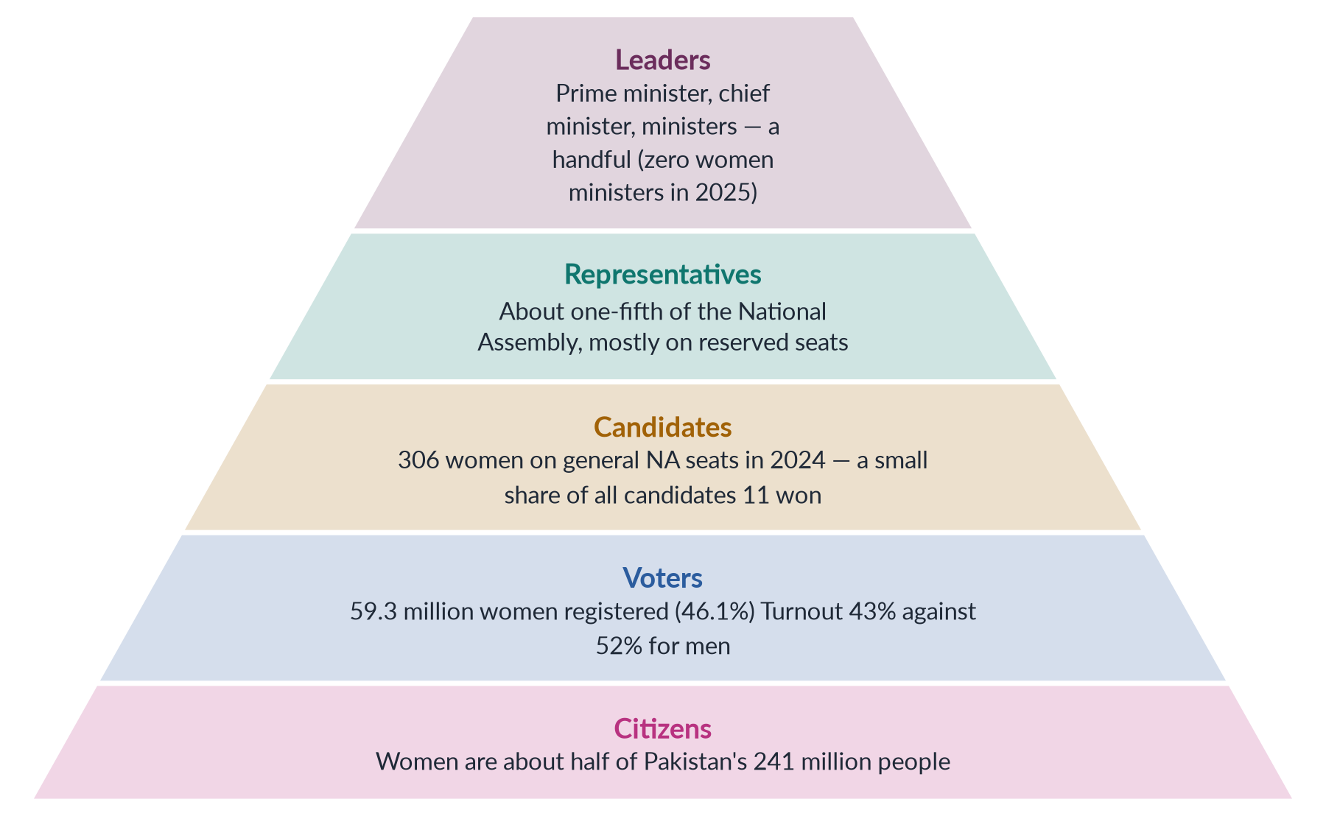
Figure 1 · The ladder of women's political participation in Pakistan — fewer women at each higher rung.
EXAMINER'S EYE · HOW THE EXAMINER USES THIS TOPIC
Most Topic 6 questions ask you to judge something: "pros and cons of gender quota… impact in Pakistan" (2016); "Is Pakistan's gender quota… showing results?" (2021); "Is political participation a human right?… impact of the political quota system" (2024); "historical context and evolution of women's quota in Pakistan" (2025). Learn for every answer: (1) the theory (representation, critical mass, quota types); (2) Pakistan's history — 1956, 1962, 1973, 1985, the lapse, 2002, 2017; (3) the current numbers from the 2024 election; (4) the barriers; and (5) a balanced judgement with reforms.

Part One — Gender and Governance

Chapter 1 · Defining Governance: Why Gender Matters to How a Country Is Run
The syllabus opens with "defining governance". No full question has yet asked for the definition alone, but every Topic 6 answer needs it in the introduction — and the theories of representation and critical mass in this chapter are the tools for judging quotas (2016, 2021, 2024, 2025) and women's impact (2017, 2018, 2022).

1.1 Government and governance
Government is the set of institutions that hold state power — parliament, cabinet, courts, the civil service. Governance is wider: it is the process by which power is used to manage a country's affairs. It includes the state, but also markets, political parties, civil society (NGOs, the media, unions) and even local bodies such as jirgas and councils.
✦ DEFINITION
Governance · World Bank (1992) and UNDP (1997)
The World Bank, in Governance and Development (1992), defined governance as "the manner in which power is exercised in the management of a country's economic and social resources for development". The UNDP (1997) described it as the exercise of economic, political and administrative authority to manage a country's affairs at all levels, through the mechanisms, processes and institutions by which citizens articulate their interests, exercise their rights, meet their obligations and mediate their differences.

The word "governance" became popular in development circles in the 1990s, after the World Bank's 1989 report on Sub-Saharan Africa blamed a "crisis of governance" for poor development. Since then, aid donors have tied loans and grants to good governance.

1.2 Good governance — the eight characteristics
The UN's regional commission for Asia (UNESCAP) lists eight characteristics of good governance, which are now standard in textbooks.
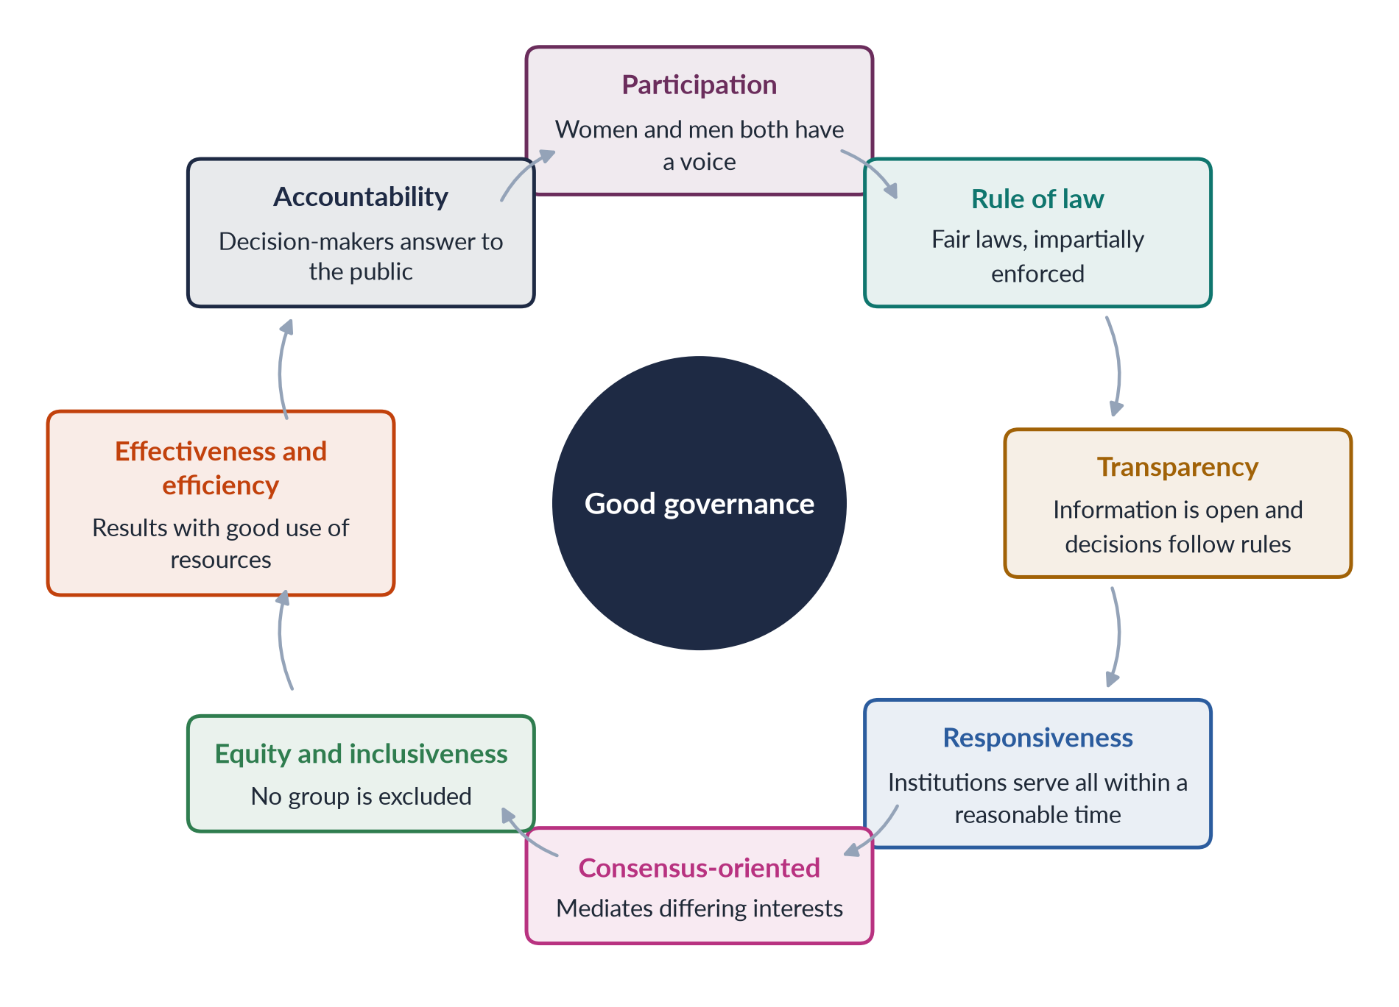
Figure 2 · The eight characteristics of good governance (UNESCAP).
Notice that participation and equity and inclusiveness are part of the definition itself. Governance from which half the population is absent cannot be "good" by this standard. The UNDP states that participation by both men and women is a cornerstone of good governance.

1.3 What "gender and governance" means
Gender and governance looks at governance through two questions:
1. Presence: Are women present in the places where decisions are made — parliament, cabinet, local councils, the civil service, courts, party leaderships, jirgas?
2. Outcomes: Do policies, budgets and laws serve women's needs as fairly as men's?
IN SIMPLE WORDS
Think of a village council deciding where to put a new water pump. If only men sit on the council, they may put it near the mosque or the market. Women, who fetch the water, might want it near the houses. Who sits at the table changes what gets decided.

Gender-responsive governance therefore has several parts:
- Women's political participation — as voters, candidates, representatives and leaders.
- Gender-responsive institutions — ministries, commissions (in Pakistan the NCSW, 2000), women's caucuses, and gender units in departments.
- Gender-responsive budgeting — examining how budgets affect women and men differently. Pakistan ran a Gender Responsive Budgeting Initiative in the Ministry of Finance in the mid-2000s.
- Accountability to women — complaint systems, ombudspersons, data broken down by sex.
✦ QUOTATION
Quaid-e-Azam Muhammad Ali Jinnah · Aligarh, 10 March 1944
"No nation can rise to the height of glory unless your women are side by side with you."
➜ Use it to open any answer on women's political participation in Pakistan: women's role in public life was part of the founding vision.

1.4 Why women's presence matters — four arguments
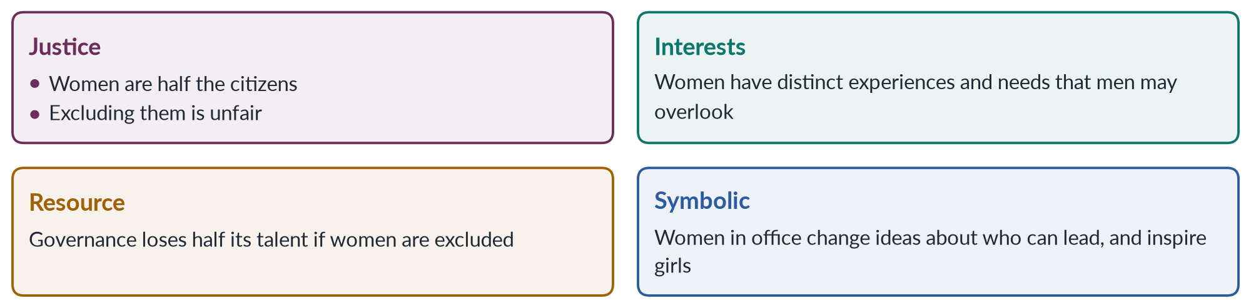
Figure 3 · Four arguments for women's presence in governance.
1. The justice argument. Women are half the population. A democracy in which they hold a tenth of the seats is not fully representative. Political equality is a human right — the Universal Declaration of Human Rights (1948), Article 21, gives everyone the right to take part in government, and CEDAW (1979), Article 7, requires states to ensure women's equal right to vote, stand for election and hold office.
2. The interests argument. Women's lives differ — in reproduction, care work, violence, work and mobility. Women representatives are more likely to raise these issues.
3. The resource argument. Excluding women wastes talent and experience; diverse bodies make better decisions.
4. The symbolic argument. Seeing women in power changes what girls and boys think is "normal", and builds trust in institutions.

1.5 Theories of representation

(1) Pitkin's four meanings of representation
The American political theorist Hanna Pitkin, in The Concept of Representation (1967), distinguished four meanings, which are now the standard way to analyse women's representation.
Table 2 · Pitkin's four meanings of representation, applied to women.
Type | Meaning | Applied to women in Pakistan
Formal | The rules that authorise representatives (elections, appointments) | Reserved seats filled from party lists; general seats by FPTP
Descriptive | Representatives resemble those they represent | About one-fifth of the National Assembly are women, against half the population
Substantive | Representatives act for the interests of the represented | Did women legislators pass laws for women? (yes — 2010–2016 laws)
Symbolic | Representatives stand for the group and shape how it is seen | Benazir Bhutto (1988) and Maryam Nawaz (2024) as role models

(2) Phillips's politics of presence
The British theorist Anne Phillips, in The Politics of Presence (1995), argued that democracy has focused on the "politics of ideas" — whether representatives hold the right views — but that who represents matters too. Men can in principle speak for women, but in practice issues such as domestic violence, maternity and childcare reached the agenda only when women were present. Presence is therefore needed for substantive representation.

(3) Critical mass, tokens and critical actors
✦ THINKER
Rosabeth Moss Kanter · *Men and Women of the Corporation* (1977)
Kanter studied women in a large American company. Where women were under about 15%, they were "tokens": highly visible, treated as symbols of all women, pressured to fit in, and isolated. As their share grew, they could form alliances and change the culture.
➜ The origin of the idea that numbers matter.

The Danish political scientist Drude Dahlerup (1988) applied this to politics as "critical mass": once women reach about 30% of a legislature, they are expected to change its culture and policies. The UN Economic and Social Council in 1990 endorsed a target of 30% women in leadership positions by 1995, and the Beijing Platform for Action (1995), Critical Area G ("women in power and decision-making"), called for gender balance.
Dahlerup herself stressed critical acts — such as adopting quotas — more than a magic number. Later scholars (Sarah Childs and Mona Lena Krook, 2009) argued that critical actors — individual women (and men) who push for women's issues — matter more than any threshold.
BALANCED VIEW · DOES CRITICAL MASS WORK?
• For: larger numbers reduce tokenism, allow alliances and make women's issues normal business; Nordic parliaments and Rwanda show visible change.
• Against: numbers alone do not guarantee change — women are divided by party, class and ideology; a few determined women can achieve a great deal; parties discipline members.
➜ Line to take: numbers create the opportunity; critical actors, cross-party caucuses and party support turn it into change. Pakistan's Women's Parliamentary Caucus (2008) is the example.

1.6 Governance spaces beyond parliament
Women's role in governance is not only about legislatures.
- The executive: cabinet ministers, chief ministers. Pakistan had no women federal ministers in the 2025 Global Gender Gap data.
- The bureaucracy: Pakistan reserves 10% of federal government posts for women, but women remain rare in senior grades.
- The judiciary: Justice Ayesha Malik became the first woman judge of the Supreme Court in 2022.
- Local government: the Devolution of Power Plan (2000) reserved 33% of council seats for women.
- Political parties: party executives decide tickets and reserved-seat lists; few women sit in them.
- Informal governance: jirgas and panchayats, which settle disputes in many areas, are almost entirely male, and have ordered vani and swara (giving girls in settlement) and honour punishments.

1.7 Gender-responsive governance in Pakistan — the machinery
Pakistan has built a set of institutions meant to make governance work for women. Knowing them helps in any answer on governance.
- Ministry and departments: a federal Women's Division (1979) became a Ministry of Women Development; after the 18th Amendment (2010) the subject moved to the provinces, which now have Women Development Departments. The federal Ministry of Human Rights (2015) handles gender at the centre.
- Commissions: the National Commission on the Status of Women (2000, made statutory by the NCSW Act 2012) reviews laws and policies; provinces have their own commissions — the Punjab Commission on the Status of Women (2014), for example.
- Policy: the National Policy for Development and Empowerment of Women (2002) set targets for women's participation in decision-making.
- Reform programmes: the Gender Reform Action Plan (GRAP), launched in the early 2000s, sought to increase women's share of public-sector jobs and make departments gender-sensitive; the Ministry of Finance ran a Gender Responsive Budgeting Initiative to analyse budgets by their effect on women and men.
- Ombudspersons: federal and provincial ombudspersons for harassment (under the 2010 law) and for women's property rights (2020).
BALANCED VIEW · HAS THE MACHINERY WORKED?
• Gains: institutions now exist at federal and provincial levels; data and reports on women's status are regular; laws have been reviewed and drafted.
• Weaknesses: small budgets, few staff, frequent changes of leadership, and weak powers to make other departments act; after 2010, provinces differ widely in capacity.
➜ Line to take: Pakistan has the machinery of gender-responsive governance; it lacks the resources and political will to make it powerful.

PAKISTAN ANGLE · THE CONSTITUTION ON WOMEN AND GOVERNANCE
Article 25 (equality; special provision for women allowed); Article 32 (representation of women in local government); Article 34 (full participation of women in all spheres of national life); Articles 51, 59, 106 (reserved seats in the National Assembly, Senate and provincial assemblies). Pakistan also signed CEDAW (1996), whose Article 7 covers political and public life.

1.8 Gender-responsive budgeting explained
A budget is the clearest statement of a government's priorities. Gender-responsive budgeting (GRB) asks how public spending and taxation affect women and men differently, and whether they reduce or widen gender gaps. It does not mean a separate "women's budget"; it means examining the whole budget through a gender lens.
- Why it matters: cuts to health, water or transport fall hardest on women, who use these services most and fill the gaps with unpaid care; spending on girls' schools, women health workers or safe transport can transform women's lives at modest cost.
- Origins: Australia pioneered "women's budget statements" in the 1980s; the Beijing Platform (1995) called on governments to integrate a gender perspective into budgetary decisions.
- Pakistan: the federal Ministry of Finance ran a Gender Responsive Budgeting Initiative in the mid-2000s, introducing gender analysis into budget call circulars, and Punjab and other provinces have produced gender analyses of their budgets.
- Limits: GRB depends on sex-disaggregated data, trained officials and political will; in Pakistan it has often remained a technical exercise without changing allocations.
IN SIMPLE WORDS
If a district spends its whole road budget on a highway used mostly by trucks, and nothing on the lanes that girls walk to school, the budget is not "neutral" — it has chosen whose journeys matter. Gender budgeting makes that choice visible.

EXAMINER'S EYE · USING THIS CHAPTER IN ANY ANSWER
Open every Topic 6 answer with a one-line definition of governance and of political participation or representation, then use Pitkin (descriptive vs substantive) or critical mass to frame your judgement. For example: "Quotas have delivered descriptive representation in Pakistan; the question is whether they have delivered substantive representation."

Chapter 2 · The Suffrage Movement: How Women Won the Vote
"Suffragist movement" was a short note in 2019, and MCQs asked what suffrage means (the right to vote, 2019) and which country first gave women the vote (New Zealand, 2024). This chapter covers the movement in the United States, Britain, the wider world and South Asia.

2.1 What suffrage means
Suffrage is the right to vote in political elections. Women's suffrage is women's right to vote on the same terms as men. Until the late nineteenth century, almost no country allowed women to vote in national elections. The suffrage movement — or suffragist movement — was the organised campaign, lasting about eighty years in the West, to win that right. It was the central demand of first-wave feminism.
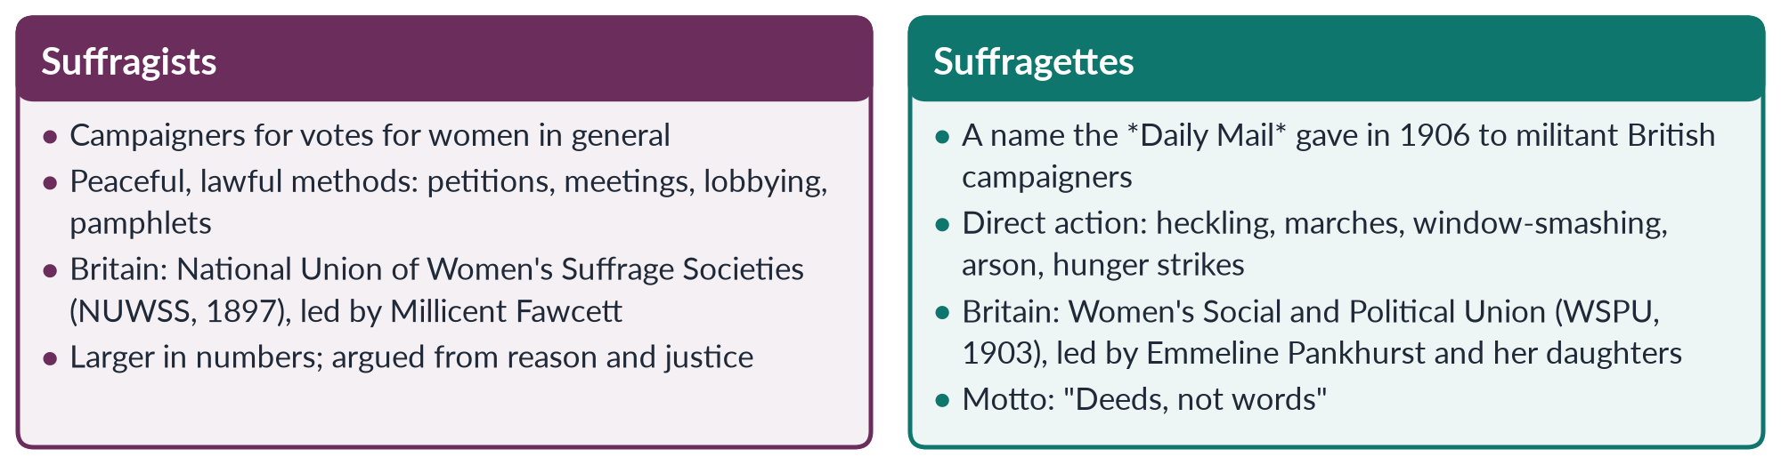
Figure 4 · Suffragists and suffragettes.

2.2 Why women were denied the vote
In the nineteenth century, voting was tied to property, independence and the "public sphere". The arguments against women's votes were:
- Separate spheres: women belonged in the home; politics was men's world.
- Coverture: a married woman's legal identity was absorbed into her husband's, so he "represented" her.
- Nature: women were said to be too emotional or weak for political judgement.
- Social order: votes for women would divide families and weaken the state.
The suffragists answered with the language of natural rights (women are human beings with equal reason), democracy (no taxation without representation), and social improvement (women would bring morality, temperance and care to politics).

2.3 The United States
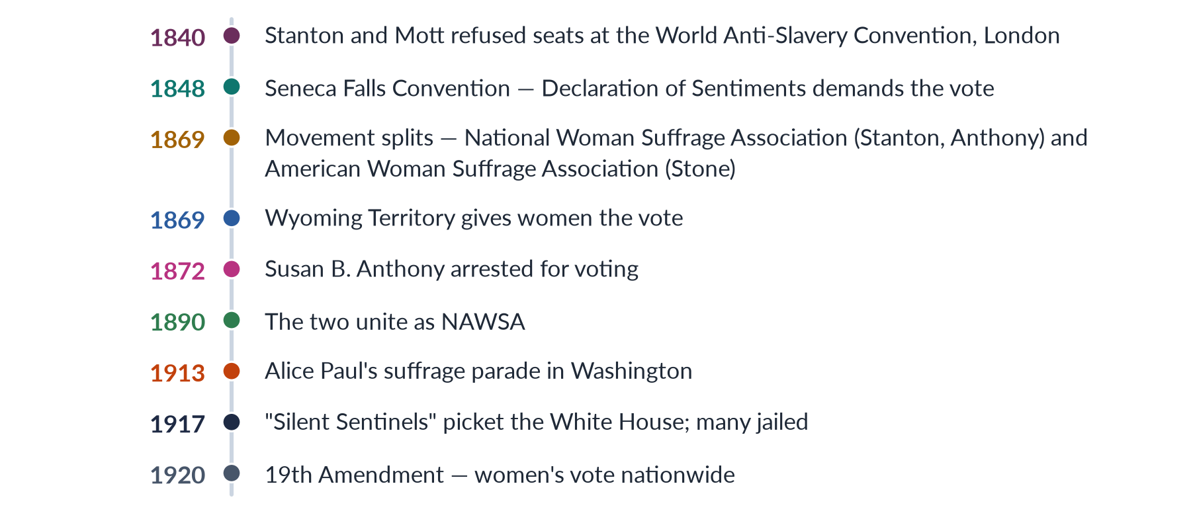
Figure 5 · The American suffrage movement.
The movement began at the Seneca Falls Convention (19–20 July 1848), organised by Elizabeth Cady Stanton and Lucretia Mott. Its Declaration of Sentiments declared that "all men and women are created equal" and demanded the vote — the most controversial resolution, supported by the abolitionist Frederick Douglass.
After the Civil War, the 15th Amendment (1870) gave the vote to Black men but not to women, splitting the movement. Susan B. Anthony and Stanton formed the National Woman Suffrage Association (1869), seeking a federal amendment; Lucy Stone formed the American Woman Suffrage Association, working state by state. They merged in 1890 as the National American Woman Suffrage Association (NAWSA). Western states — Wyoming (1869), Utah, Colorado, Idaho — gave women the vote first.
In the 1910s, Alice Paul's more militant National Woman's Party picketed the White House; arrested pickets went on hunger strike and were force-fed. Women's war work in the First World War strengthened their case. The 19th Amendment (ratified 1920) declared that the right to vote shall not be denied "on account of sex". Many Black women in the South, however, remained barred by discriminatory laws until the Voting Rights Act of 1965.

2.4 Britain
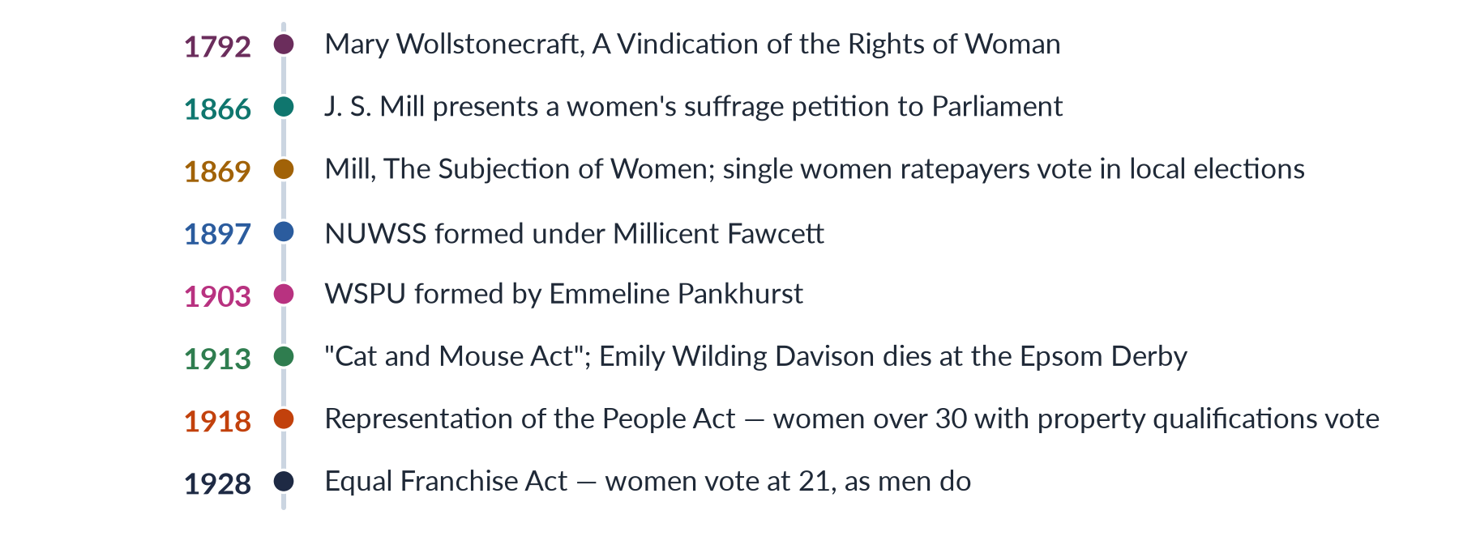
Figure 6 · The British suffrage movement.
In 1866 John Stuart Mill, then an MP, presented a petition for women's suffrage and in 1867 proposed amending the Reform Bill to replace "man" with "person"; it failed. His book The Subjection of Women (1869) became a classic of liberal feminism.
The suffragists of the NUWSS (1897), led by Millicent Fawcett, used patient, lawful pressure. Frustrated by slow progress, Emmeline Pankhurst founded the WSPU (1903). Its suffragettes heckled ministers, chained themselves to railings, smashed windows and set fire to post boxes. Imprisoned suffragettes went on hunger strike; the government force-fed them, then passed the Prisoners (Temporary Discharge for Ill-Health) Act (1913) — the "Cat and Mouse Act" — releasing them when weak and re-arresting them when recovered. In 1913 Emily Wilding Davison ran onto the course at the Epsom Derby and was struck by the King's horse; she died days later.
During the First World War (1914–18) both groups suspended campaigning and supported the war effort, while women worked in munitions factories and services. The Representation of the People Act (1918) gave the vote to women over 30 who met property qualifications (about 8.4 million women). The Equal Franchise Act (1928) gave women the vote at 21, on equal terms with men.

2.5 The wider world
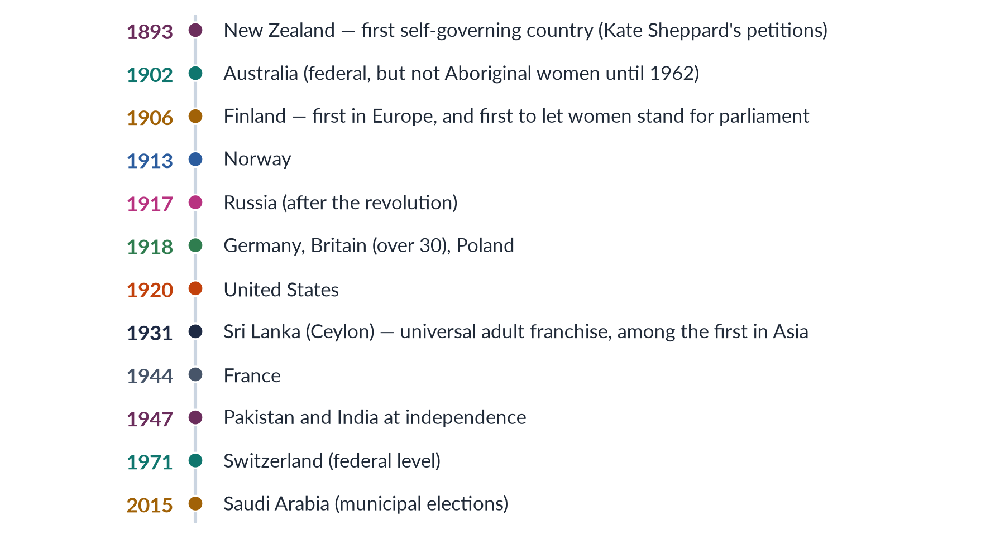
Figure 7 · When women won the vote — selected countries.
New Zealand (1893) was the first self-governing country to give all women the vote, after petitions organised by Kate Sheppard gathered about 32,000 signatures. Finland (1906) was the first to let women both vote and stand; 19 women entered its parliament in 1907. Women in many countries won the vote after the First World War, and in France and Italy after the Second. In much of Asia and Africa women gained the vote with independence from colonial rule, often at the same time as men.

2.5a Suffrage in the Muslim world
Women's suffrage came to Muslim-majority countries at different times, usually with modern statehood.
- Azerbaijan (1918) is often cited as the first Muslim-majority country to give women the vote, during its short-lived democratic republic.
- Turkey gave women the vote in local elections in 1930 and national elections in 1934, under Atatürk's reforms; eighteen women entered parliament in 1935.
- Pakistan (1947), Indonesia (1945) and Bangladesh (1971) began with adult franchise at independence.
- Iran gave women the vote in 1963; Kuwait in 2005; Saudi Arabia in municipal elections in 2015.
These dates show that the Muslim world is not uniform: many Muslim-majority countries gave women the vote before Switzerland (1971). Today Muslim-majority states such as Pakistan, Bangladesh, Indonesia and Tunisia use gender quotas, and Pakistan, Bangladesh, Turkey and Indonesia have had women heads of government.

2.6 Suffrage in South Asia
In colonial India, women's political rights grew step by step.
1. 1917: The Women's Indian Association (Annie Besant, Margaret Cousins, Dorothy Jinarajadasa) and Sarojini Naidu led a delegation to the Secretary of State, Edwin Montagu, demanding the vote on the same terms as men.
2. 1919: The Government of India Act left the question to provincial legislatures. Madras (1921) became the first province to enfranchise women, on property qualifications; others followed.
3. 1935: The Government of India Act extended the vote to about six million women and reserved seats for women in the legislatures — the origin of reserved seats in the subcontinent.
4. 1937–46: Women contested elections; the All-India Muslim League formed a women's sub-committee in 1938. Women such as Begum Jahanara Shahnawaz and Begum Shaista Ikramullah became leaders.
5. 1947: Pakistan began with adult franchise for women and men. The first Constituent Assembly had two women — Jahanara Shahnawaz and Shaista Ikramullah (MCQs 2016, 2024).
PAKISTAN ANGLE · WOMEN VOTERS IN PAKISTAN'S EARLY YEARS
Women voted in Pakistan's provincial elections from the start. The 1956 Constitution confirmed universal adult franchise, and the first direct nationwide general election, in 1970, was held on it. In the 1965 presidential election, Fatima Jinnah challenged Ayub Khan — the first woman to contest for the country's highest office. The voting age was lowered from 21 to 18 in 2002 (MCQ 2016).

2.6a The ideas behind the movement — justice and expediency
The suffragists used two families of argument, and historians still debate which mattered more.
1. Justice (equal rights) arguments: women are rational human beings with the same natural rights as men. Mary Wollstonecraft (A Vindication of the Rights of Woman, 1792) argued that women seem inferior only because they are denied education; the Declaration of Sentiments (1848) rewrote the Declaration of Independence to say that "all men and women are created equal"; John Stuart Mill (The Subjection of Women, 1869) argued that the legal subordination of women was wrong in itself and a barrier to human progress.
2. Expediency (difference) arguments: women would improve politics because of their distinct qualities — as mothers and moral guardians they would support temperance, child welfare, public health and peace. These arguments, common in the later movement, reassured opponents that votes for women would not overturn the family.
BALANCED VIEW · WHICH ARGUMENT WON THE VOTE?
• Justice gave the movement its principle and its link to democracy.
• Expediency — together with women's war work in 1914–18 — persuaded many reluctant politicians.
➜ Line to take: the vote was won by a combination of principle, practical argument, organisation (suffragists) and pressure (suffragettes), at a moment when war had changed ideas of citizenship.

2.7 Achievements and limits of the suffrage movement
BALANCED VIEW · ASSESSING THE SUFFRAGE MOVEMENT
• Achievements: won the vote and the right to stand in most of the world; trained generations of women in organising; linked feminism to democracy; opened the way to education, property and legal reforms.
• Limits: many suffragists were white, middle-class and sometimes racist or class-biased (Black women in the US South; working-class women in Britain under the 1918 property rule); the vote did not end discrimination in law, work or the family — which led to the second wave; formal rights did not ensure real participation.
➜ Line to take: suffrage was a necessary but not sufficient step. Pakistan shows this clearly — women have voted since 1947, but in 2024 there were still 9.94 million fewer women than men on the electoral roll.

EXAMINER'S EYE · THE MODEL STRUCTURE FOR THE 2019 SHORT NOTE
1. Meaning: suffrage = the right to vote; suffragist vs suffragette. 2. Origins: Wollstonecraft, Seneca Falls (1848). 3. United States: NWSA/AWSA 1869, NAWSA 1890, 19th Amendment 1920. 4. Britain: Mill 1866, NUWSS 1897, WSPU 1903, 1918 and 1928. 5. The world: New Zealand 1893, Finland 1906. 6. South Asia: 1917 delegation, Madras 1921, 1935 Act, Pakistan 1947. 7. Assessment: necessary but not sufficient. Draw the world timeline.

Chapter 3 · Women as Voters: The Gender Gap at the Ballot Box
The syllabus names "gender issues in women as voters". The 2017 and 2024 questions on women's political participation need this chapter, and a 2016 MCQ asked the minimum voting age (18).

3.1 Voting as the first rung of participation
Voting is the most basic form of political participation. It is how citizens choose representatives and hold them to account. If women do not vote, or vote as others tell them, politicians have less reason to address their needs. A woman's vote is also a sign of her status as a citizen in her own right, not only as a member of a family.
Pakistan's women have had the legal right to vote since independence. The problem is not the law but practice: millions of women are not registered, fewer of those registered turn out, and some are prevented from voting or told how to vote.

3.2 The registration gap
To vote in Pakistan, a citizen must be on the electoral roll, which the Election Commission of Pakistan (ECP) prepares from NADRA's identity-card database. A person without a Computerised National Identity Card (CNIC) cannot be registered. Far fewer women than men have CNICs.
✦ DATA
Registered voters, 2024 general election · ECP / FAFEN
128.58 million registered voters: 69.26 million men (53.9%) and 59.32 million women (46.1%). The gender gap was 9.94 million — 7.7% of the electorate — down from 12.8% in 2013.

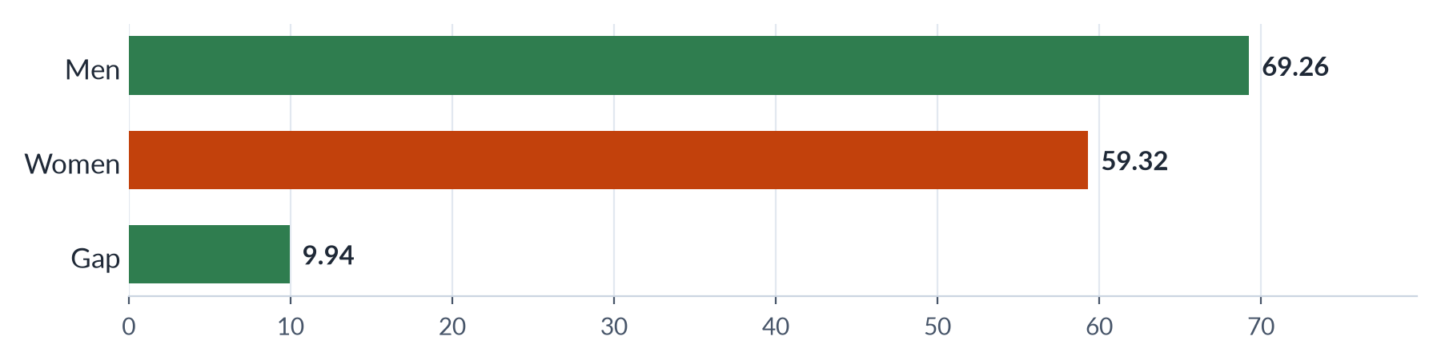
Figure 8 · The registration gap: men and women on Pakistan's electoral roll, 2024 (millions).

Why women are missing from the roll
1. No CNIC. Many women, especially in rural areas, never obtain an identity card: families see no need, the NADRA office is far away, and travel needs a male escort.
2. Documents. Women married young or without registered births find it hard to prove identity.
3. Mobility and cost. Travel to NADRA centres costs money and time.
4. Family control. Some families keep women's cards or refuse to let them register.
5. Low awareness. Many women do not know that registration is needed or how to do it.

Closing the registration gap
The registration gap narrowed sharply after the 2018 election because of deliberate action: the ECP and NADRA ran special drives with mobile registration vans, waived CNIC fees for women at times, set up women-only counters, and worked with NGOs such as the Aurat Foundation and the Free and Fair Election Network (FAFEN). The Elections Act 2017 required the ECP to take special measures where the gap in a district exceeds 10%.

3.3 The turnout gap
Being registered is not the same as voting.
✦ DATA
Turnout, 2024 general election · FAFEN
Women's turnout was about 43%, men's about 52% — a gap of 9 points, down from 10 in 2018. Women cast 24.4 million of the 58.9 million votes — 2.7 million more than in 2018, nearly double the growth in men's votes. The gap was widest in Khyber Pakhtunkhwa (about 15.7 points) and narrowest in Sindh (about 7.4).

Why women vote less
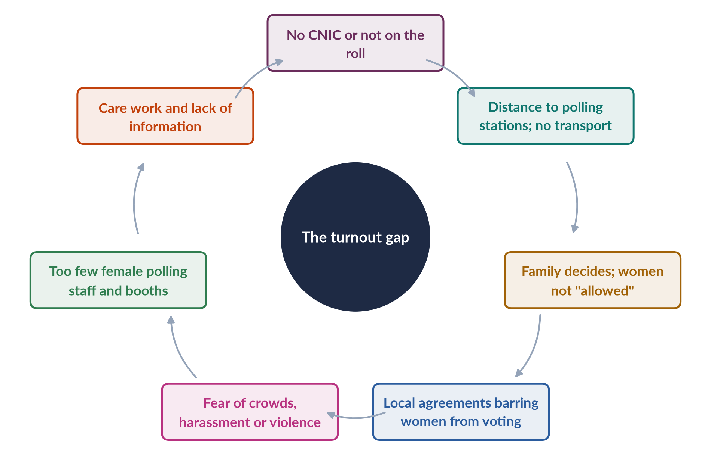
Figure 9 · Why many Pakistani women do not vote.
1. Family and community control. In many areas the household head decides whether — and for whom — women vote.
2. Agreements to bar women. In some constituencies of Khyber Pakhtunkhwa and Punjab, candidates, elders and even rival parties have made local agreements that women will not vote. In 2015 the ECP annulled a provincial by-election in Lower Dir because women had been kept away.
3. Distance and security. Polling stations may be far; women may fear crowds, harassment or violence.
4. Polling arrangements. Too few female polling stations or booths and female staff to check identities of veiled women.
5. Care and information. Household duties and less access to campaign information.

3.4 The 10% rule — a legal remedy
✦ LAW & POLICY
Elections Act 2017 · Section 9 — women's turnout
If the turnout of women voters in a constituency is less than 10% of the total votes polled, the ECP may presume that women were restrained from voting through an agreement and may declare the poll in that constituency, or at particular polling stations, void.
➜ A strong deterrent: candidates now have an interest in getting women to vote. Elections in some constituencies have been re-held under this rule.

3.5 Voting independently — the question of autonomy
Even when women vote, they may not choose freely. Research in Pakistan finds that many women vote as their husbands, fathers or biradari (clan) decide. Women's votes are often "block votes" negotiated by male elders. This matters because a vote that is not one's own does not give a woman political power.
Factors that increase women's independent voting include education, paid work, media access, and contact by women campaigners and party workers. Studies by economists in Pakistan found that door-to-door awareness campaigns aimed at women raised both their turnout and their independence of choice.
IN SIMPLE WORDS
Being on the list, getting to the polling station, and choosing for yourself are three separate steps. Pakistan has made progress on the first two; the third is the hardest.

3.6 Do women vote differently?
In many Western democracies a "gender gap" in voting preference has appeared: since the 1980s, women in the United States have tended to vote more for the Democratic Party, and young women in many countries have moved to the left of young men. In Pakistan, evidence of a distinct women's vote is weaker, because of family voting. But parties increasingly court women voters: the Benazir Income Support Programme (2008), paid to women, and provincial schemes for women have been seen as ways to win women's support.

3.6a Why the CNIC matters beyond voting
The identity card is the key to citizenship in Pakistan. Without a CNIC a woman cannot vote, but she also cannot open a bank account, receive BISP cash transfers, register a SIM card, claim inheritance or property, or get a passport. Campaigns to register women as voters therefore also bring them into the economy and the welfare system. The Benazir Income Support Programme (2008), paid only to women with CNICs, was one of the biggest drivers of women's registration — a good example of how social policy and political participation reinforce each other.

3.6b Violence and intimidation
Elections in Pakistan have often been marked by violence. Women voters face particular risks: rumours or threats can keep them home, polling stations for women may be targeted, and in militancy-affected areas extremists have warned women against voting. Women polling staff — teachers and civil servants on duty — also face harassment. Safe, nearby women's polling stations, women police and security for women voters are therefore part of the solution, not just registration drives.

3.6c Women voters across the provinces
The national averages hide large regional differences, which FAFEN's analysis of the 2024 election made clear.
- Khyber Pakhtunkhwa had the widest gender gap in turnout — about 15.7 percentage points — reflecting conservative norms in many districts, past agreements to keep women from voting, and insecurity.
- Sindh had a gap of about 7.4 points — roughly half of KP's — with relatively higher women's participation in many districts.
- Punjab, with the largest electorate, saw the biggest absolute growth in women's votes.
- Women's share of votes polled in National Assembly constituencies rose from 39.4% in 2018 to 41.4% in 2024.
Within each province, the gap is usually widest in rural, tribal and low-literacy constituencies and narrowest in cities. This pattern matches the causes in Section 3.3: where mobility is restricted, CNIC coverage is low and family control is strong, women vote least. It also shows where policy should focus — mobile registration, women's polling stations and voter education in the districts with the widest gaps.

3.7 Policy: bringing women to the ballot box
1. Universal CNICs — free, mobile registration for women; link to BISP and health cards.
2. Enforce Section 9 — void polls where women are barred; prosecute those who make agreements.
3. More female polling stations and staff, closer to homes, with safe transport.
4. Voter education in local languages through Lady Health Workers, schools, radio and mobile phones.
5. Party responsibility — women's wings, women canvassers and manifestos that address women.
6. Data — publish sex-disaggregated turnout for every polling station (now done by the ECP and FAFEN).
BALANCED VIEW · IS THE VOTER GENDER GAP CLOSING?
• Progress: the registration gap fell from 12.8% (2013) to 7.7% (2024); women's votes grew by 2.7 million in 2024; the 10% rule deters open bans.
• Problems: 9.94 million women still unregistered; turnout 43% against 52%; family voting limits real choice.
➜ Line to take: the legal right is secure and the access gap is closing, but autonomy — women choosing for themselves — remains the deepest challenge.

Chapter 4 · Women as Candidates: Getting onto the Ballot
The syllabus names "gender issues in women as candidates". The 2024 question asked "what obstacles are faced by women politicians in Pakistan in pursuing a career in politics?", and the 2018 question asked whether we need equal numbers of women in politics.

4.1 The candidate stage — where women drop out
Voting is a right every adult can use; standing for office requires resources, networks and a party ticket. This is where most women drop out of politics. Political scientists describe the path to office as a pipeline with three filters:
1. Eligibility — who could stand (all adult citizens meeting legal conditions).
2. Aspiration — who wants to stand.
3. Selection — whom parties choose, and whom voters elect.
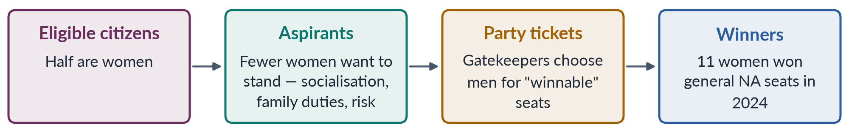
Figure 10 · The candidate pipeline: where women leak out.
✦ DATA
Women candidates, 2024 general election · ECP / IFES
306 women contested general seats for the National Assembly; 11 won — 5 independents, 4 from PML-N and 2 from PPP. In 2018 8 women won general seats; in 2013 5 won at the general election (10 including by-elections).

4.2 The legal framework
- Any citizen aged 25 or over who is on the electoral roll may contest a National Assembly or provincial seat (Article 62 sets further conditions).
- From 2002 to 2008 candidates had to hold a graduate (BA) degree — a rule that excluded many rural women and men, and was dropped in 2008.
- The Elections Act 2017, Section 206, requires every party to give at least 5% of its tickets for general seats to women.
✦ LAW & POLICY
Elections Act 2017 · Section 206 — women's tickets
A political party shall, while making the selection of candidates for elected bodies, ensure at least five per cent representation of women candidates on general seats.
➜ A legislated candidate quota, the first in Pakistan's history. But it is weak: it does not say which seats, so parties often give women tickets in constituencies they expect to lose.

4.3 Barriers to women's candidacy
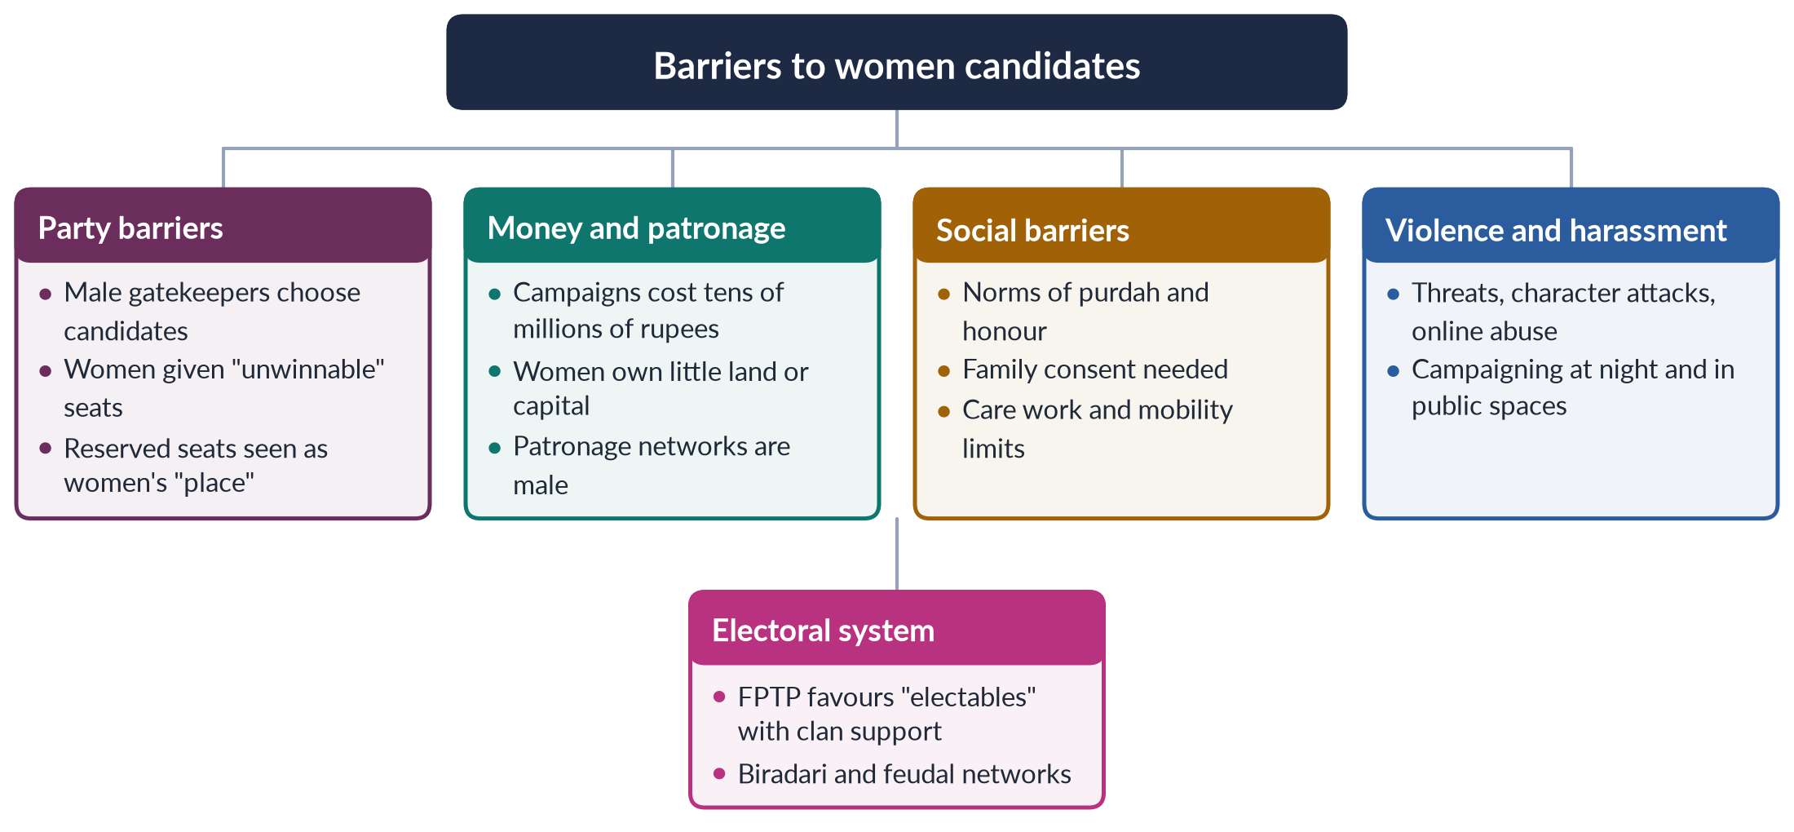
Figure 11 · The barriers facing women candidates in Pakistan.

(1) Party gatekeeping
Political parties decide tickets, and their leaderships are overwhelmingly male. Parties prefer "electables" — candidates with landholdings, clan (biradari) support and money — who are mostly men. Many party leaders also see reserved seats as the proper route for women, so they see no need to give women general tickets.

(2) Money
Campaigns for a National Assembly seat cost huge sums — for posters, rallies, transport on polling day and payments to local power brokers. Women own little land or capital and have less access to business donors. Election spending limits are often ignored.

(3) Social norms and family
Campaigning means travelling, meeting male voters, attending gatherings at night and appearing in public — all difficult where purdah and family honour restrict women's mobility. Women need family consent, and many must balance politics with care work.

(4) Violence and harassment
Women candidates face character assassination, threats, and increasingly online abuse. In some areas women have faced threats from militants. Fear of violence deters women from standing at all.

(5) The electoral system
Under first-past-the-post, one candidate wins each constituency. Parties then pick the "safest" candidate — usually a man with local networks. Proportional representation with list quotas, as Nepal uses, tends to elect more women.

(6) Dynasties — door-opener and limit
Many women who win general seats come from political families — daughters, wives or widows of politicians. Dynasties open doors for some women, such as Benazir Bhutto (daughter of Zulfikar Ali Bhutto) and Maryam Nawaz (daughter of Nawaz Sharif). But they keep politics closed to women without such connections.
BALANCED VIEW · ARE DYNASTIC WOMEN "REAL" POLITICIANS?
• Critics: dynastic women are proxies for male relatives; their success says nothing about ordinary women's chances.
• Defenders: many dynastic women became strong leaders in their own right — Benazir Bhutto led a party and twice became prime minister; dynasties are common among male politicians too.
➜ Line to take: dynasty is a route, not a disqualification; the problem is that it is almost the only route for women.

4.3a Electoral systems and women — FPTP versus proportional representation
The type of electoral system is one of the strongest predictors of how many women are elected.
Table 3 · How electoral systems affect women's election.
Aspect | First-past-the-post (FPTP) | Proportional representation (PR)
How it works | One winner per constituency — the candidate with the most votes | Seats shared by parties according to vote share, usually from lists
Party's incentive | Pick the single "safest" candidate — usually a man with local networks | Present a balanced list that appeals to all voters
Effect on women | Women rarely chosen in winnable seats | Easier to include women; quotas can require alternating ("zipper") lists
Examples | Pakistan's 266 general seats; India; UK | Nordic countries; Nepal's PR seats; Pakistan's reserved seats

Pakistan uses both: FPTP for its 266 general seats, where only 11 women won in 2024, and a PR-like allocation for its 60 reserved seats. The contrast is striking — women are almost absent where parties must choose one candidate, and guaranteed only where seats are allocated from lists. Nepal's mixed system shows the same pattern: women won about 35% of all seats in 2026 but only 14 of the FPTP seats.
Reform options that keep direct election but help women include dual-member constituencies (each with one woman), rotating reserved constituencies (a different set reserved for women at each election, as in India's panchayats), or a stronger candidate quota requiring parties to field women in seats they won or came close to winning last time. Each would give women a constituency and voters of their own, rather than dependence on a party list.

4.4 Why fewer women aspire to stand
Even before parties choose, fewer women want to stand. Research in many countries shows that women are less often encouraged to run, more likely to doubt their qualifications, and more concerned about the effect on their families. In Pakistan, socialisation — the message that politics is "dirty" and a man's world — reinforces this. Encouragement from party leaders, mentors and women's networks raises women's political ambition.

4.5 Cases of women candidates
✦ CASE
Benazir Bhutto (1953–2007) · the first woman prime minister of a Muslim-majority country
Chairperson of the PPP after her father's execution, she led the party to victory in 1988 and became Pakistan's (and the Muslim world's) first woman prime minister (MCQ 2018); she served again from 1993 to 1996. She was assassinated in Rawalpindi on 27 December 2007 while campaigning.
➜ Shows both the possibility of women's leadership and the violence women politicians can face.

✦ CASE
Women winners on general seats, 2024 · breaking through
Eleven women won general National Assembly seats in 2024, the highest number in years. They included party leaders and dynastic candidates as well as independents backed by PTI. Yet 11 of 266 general seats is only about 4%.

4.5a Women candidates in local government
Local councils are where most Pakistani women have actually stood for office. Under the Local Government Ordinance 2001, 33% of seats were reserved for women and filled by direct or indirect election; about 36,000 women were elected in 2000–01. In conservative areas, some seats went unfilled because no women were allowed to file papers, and some winners were proxies for male relatives. But many women gained confidence, public experience and respect, and some later won provincial seats. Under the provincial local government laws of the 2010s, women's seats continued but at lower shares in most provinces. Local quotas are the training ground that a strong candidate pipeline needs.

4.5b Online harassment — a new barrier
Social media has become a main campaign tool, and with it has come a new barrier. Women candidates and legislators face trolling, doctored images, sexual slurs and threats online — attacks on their character rather than their policies. The Prevention of Electronic Crimes Act (2016) criminalises some of this, and the Digital Rights Foundation helpline (2016) supports victims, but enforcement is weak. Research in many countries shows that online abuse leads some women to withdraw from politics or never enter it.

4.6 Policy: getting more women on the ballot
1. Strengthen Section 206 — raise the quota (many activists propose 10–33%) and require tickets in winnable seats, for example by counting only seats the party won or came second in last time.
2. Sanctions — refuse election symbols or public funds to parties that fail to comply.
3. Campaign finance — enforce spending limits; give public funds or free airtime to women candidates.
4. Party reform — quotas for women in party executives and ticket committees.
5. Safety — act against violence and online harassment of women candidates.
6. Pathways — use local government seats as a training ground, then move women to provincial and national tickets.
EXAMINER'S EYE · USING THIS CHAPTER
For "obstacles faced by women politicians" (2024), organise barriers as party, money, social, violence, system, and give the data: 306 contested, 11 won (2024); 5% tickets under Section 206.

Chapter 5 · Women as Representatives: Inside the Assemblies
The syllabus names "gender issues in women as representatives". The 2022 question asked: "In your opinion, what are the main issues faced by women as representatives in Pakistan?" The 2021 question asked whether the quota is "showing results".

5.1 How many women sit in Pakistan's legislatures
Table 4 · Women's seats in Pakistan's legislatures.
House | Total seats | Reserved for women | Notes
National Assembly | 336 | 60 | 266 general seats (11 women won in 2024) and 10 for non-Muslims
Senate | 96 | 17 | 4 per province and 1 for Islamabad; 18 women senators in 2024
Punjab Assembly | 371 | 66 | Largest provincial reserved quota
Sindh Assembly | 168 | 29 | —
Khyber Pakhtunkhwa Assembly | 145 | 26 | Increased after the merger of the tribal areas (2018)
Balochistan Assembly | 65 | 11 | —

With the 60 reserved seats and a handful of general-seat winners, women hold roughly one-fifth of the National Assembly — about the world average of a little over a quarter, but far below parity.
IN SIMPLE WORDS
Reserved seats are not contested directly by voters. After the election, each party gets a share of the women's seats in proportion to the general seats it won, and fills them from a priority list of women it submitted earlier. So a reserved-seat member owes her seat to her party, not to a constituency.

5.2 Two classes of women members
Pakistan's system creates two kinds of women legislators:
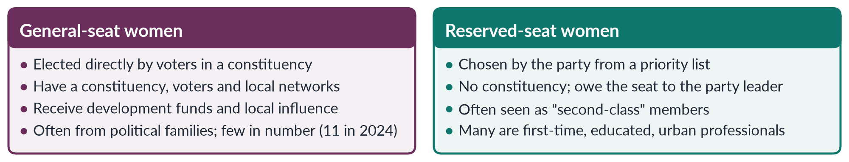
Figure 12 · Women on general seats and women on reserved seats.

5.3 The main issues faced by women representatives (2022)
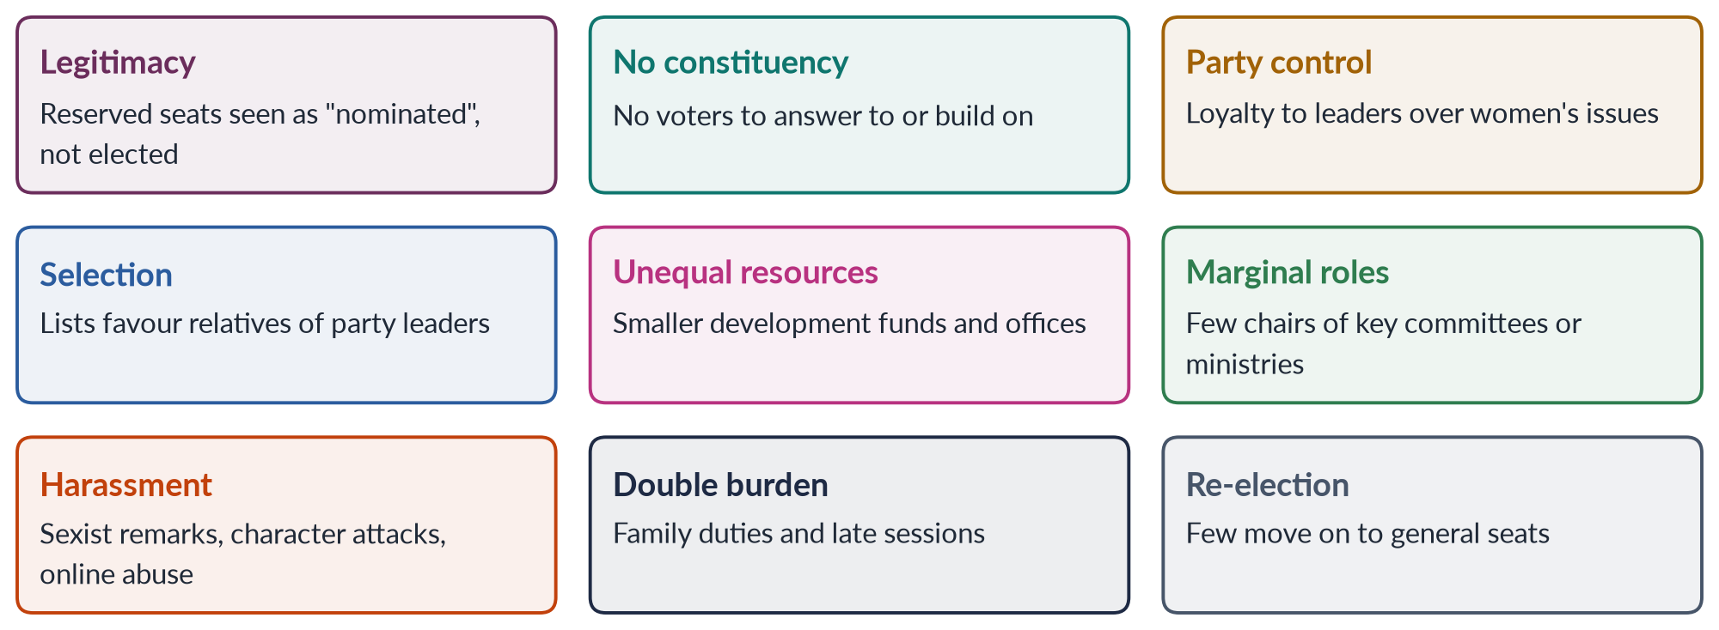
Figure 13 · The main issues faced by women representatives in Pakistan.

(1) Legitimacy and the "nominated" label
Because reserved-seat women are not directly elected, colleagues and the public often treat them as nominated rather than elected — "token" members. Male legislators have sometimes dismissed their views on the floor of the House.

(2) No constituency
Without a constituency, reserved-seat women have no voters to serve, no local base to build, and no clear way to show performance. This also makes it hard for them to win a general seat later.

(3) Dependence on party leaders
Reserved seats are filled from party lists drawn up by party leaderships. Places on the list often go to relatives of party leaders, loyal workers or donors' families. Since their future depends on the leader's favour, women members find it risky to break party line — even on women's issues. A dispute in 2024–25 over whether reserved seats should go to PTI-backed independents, which reached the Supreme Court, showed how completely the seats depend on party arithmetic.

(4) Unequal resources and roles
Women members, especially on reserved seats, have often received smaller shares of development funds, fewer committee chairs, and fewer ministries — usually "soft" portfolios such as women's development, social welfare or education rather than finance, interior or foreign affairs. In 2025 there were no women federal ministers.

(5) Harassment and sexism
Women legislators have faced sexist remarks in the assemblies, comments on their appearance, and character attacks in the media and online. Such incidents, often widely reported, discourage women from politics.

(6) Family duties and working conditions
Long, late sessions, travel and the absence of childcare facilities in assemblies make the work harder for women with families.

(7) Capacity and information
Many reserved-seat women are first-time legislators. Without training, research staff and access to information, they find it hard to draft bills, scrutinise budgets and use parliamentary procedures — though training programmes by parliament, NGOs and donors have helped.

5.4 How women representatives have responded
✦ CASE
The Women's Parliamentary Caucus (2008) · working across party lines
Formed in 2008 under the patronage of Dr Fahmida Mirza, the first woman Speaker of the National Assembly (MCQs 2016, 2019), the caucus brought women members of all parties together. It pushed the laws of 2010–2016: the workplace harassment law (2010), the Acid Control and Anti-Women Practices laws (2011), the NCSW Act (2012) and the honour-killing and anti-rape laws (2016). Provincial assemblies formed their own caucuses.
➜ The best example of substantive representation and of critical actors at work.

Women legislators have also been among the most active members in parliamentary monitoring by FAFEN and PILDAT — moving questions, resolutions and private members' bills out of proportion to their numbers.

5.4a Women in the Senate and the provincial assemblies
- Senate: women's 17 seats (four per province and one for Islamabad) are filled by the provincial and national assemblies by single transferable vote, so Senate women also depend on party strength. Women senators have introduced important bills — the anti-honour-killing bill of 2014 was moved by Senator Sughra Imam.
- Provincial assemblies: the 132 reserved seats give women a presence in all four provinces. Provincial women's caucuses pushed the domestic violence laws of Sindh (2013), Balochistan (2014), Punjab (2016) and Khyber Pakhtunkhwa (2021). Since the 18th Amendment moved most social policy to the provinces, provincial women legislators matter more than ever.
- Local councils: women councillors deal with water, sanitation, schools and health — the issues closest to women's daily lives.

5.5 Notable women in Pakistan's legislatures and offices
Table 5 · Pakistani women "firsts" in governance (many are MCQ answers).
Year | Person | First
1947 | Jahanara Shahnawaz, Shaista Ikramullah | The two women members of the first Constituent Assembly
1965 | Fatima Jinnah | First woman to contest a presidential election (against Ayub Khan)
1973 | Ra'ana Liaquat Ali Khan | First woman governor (Sindh)
1988 | Benazir Bhutto | First woman prime minister
2008 | Fahmida Mirza | First woman Speaker of the National Assembly
2011 | Hina Rabbani Khar | First woman foreign minister
2017 | Tehmina Janjua | First woman foreign secretary (MCQ 2018)
2022 | Ayesha Malik | First woman judge of the Supreme Court
2024 | Maryam Nawaz | First woman chief minister (Punjab)

5.5a Lessons from other parliaments
- Rwanda: after the 1994 genocide, the 2003 constitution reserved 30% of seats for women; women now hold over 60% of the lower house — the highest share in the world — and have led reforms on inheritance and gender-based violence.
- The Nordic countries: voluntary party quotas and proportional representation produced women's shares of 40% or more, alongside childcare and parental-leave policies that make political careers compatible with family life.
- The United Kingdom: the Labour Party's all-women shortlists in selected constituencies helped elect 101 Labour women MPs in 1997, more than doubling women's representation at a stroke.
- Nepal: a constitutional one-third with PR lists produced about 35% women in 2026, but only 14 won directly — showing that list quotas can raise numbers without breaking the barrier on direct seats.
The lesson for Pakistan is that design matters: quotas linked to direct election or winnable constituencies, party rules and family-friendly parliaments all change what women can do once elected.

5.6 Making representation work
1. Constituencies for reserved seats — options include giving reserved-seat members defined areas, or moving to direct election of women's seats (e.g. reserved constituencies rotating every election, as India's panchayats do).
2. Transparent party lists — open criteria and party elections for list places.
3. Equal resources — equal development funds, offices and staff for all members.
4. Committee roles and ministries — women chairs of key committees; women in "hard" portfolios.
5. Codes of conduct — sanctions for sexist remarks and harassment in the assemblies.
6. Family-friendly assemblies — day-care centres, sensible sitting hours.
7. Capacity — research support, training and mentoring.
BALANCED VIEW · ARE WOMEN REPRESENTATIVES EFFECTIVE?
• Yes: the caucus passed landmark laws; women members are active in debates and questions; their presence has made violence and harassment normal business of parliament.
• Limited: women are dependent on party leaders; few hold real power; reserved seats have not produced many general-seat winners; issues such as economic policy remain male domains.
➜ Line to take: women representatives have made a real difference on women's issues despite structural constraints; the reforms above would let them do more.

Chapter 6 · Gender Quotas: Types, Arguments For and Against
Quotas are the examiner's favourite line in Topic 6. "What are the pros and cons of gender quota in politics?" (2016); "Women need to be in leadership positions to pull more women into leadership roles… or is it inappropriate preferential treatment?" (2020); "Is Pakistan's gender quota in parliament showing results?" (2021); "What is the impact of the political quota system?" (2024).

6.1 What a gender quota is
A gender quota is a rule that requires a minimum number or share of women in a body — a legislature, a candidate list, a party executive, a company board or a public service. Quotas are a form of affirmative action (also called positive discrimination or special measures): temporary steps to correct historical disadvantage.
✦ LAW & POLICY
CEDAW (1979) · Article 4(1) — temporary special measures
Adoption by states of temporary special measures aimed at accelerating de facto equality between men and women shall not be considered discrimination; such measures shall be discontinued when the objectives of equality have been achieved.
➜ The international legal basis for quotas. Pakistan's Article 25(3) similarly allows "special provision for the protection of women and children".

6.2 Types of quota
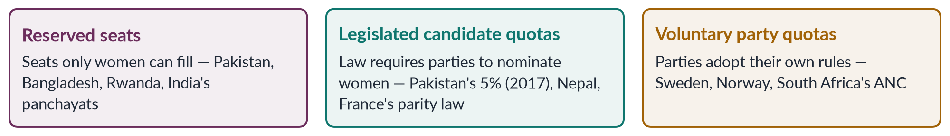
Figure 14 · The three main types of political gender quota (after Dahlerup and Krook).
1. Reserved seats guarantee a result: a fixed number of women will sit in the legislature, however voters vote. Pakistan's 60 National Assembly seats and Bangladesh's 50 are examples.
2. Legislated candidate quotas guarantee opportunity: parties must nominate a share of women, but voters decide whether they win. Effects depend on placement — in list systems, rules such as "zipper" lists (alternating women and men) make them effective.
3. Voluntary party quotas are adopted by parties themselves, common in Scandinavia, where they helped women reach over 40% of parliaments.
Quotas also exist at local level (India's one-third of panchayat seats, 1992; Pakistan's 33% in 2000–01) and in other bodies (Norway's 40% quota for company boards, 2003; Pakistan's 10% quota in federal jobs).
✦ DATA
Quotas around the world · IPU and International IDEA
More than 130 countries use some form of political gender quota. Women's share of seats in national parliaments worldwide is a little over 27%. Rwanda, with reserved seats under its 2003 constitution, has had the world's highest share — over 60% of its lower house.

6.2a "Quotas are a Western idea" — an objection answered
Some critics in Pakistan argue that quotas are a Western import that conflicts with local culture or religion. The evidence does not support this:
- Reserved seats for women in the subcontinent date back to the Government of India Act 1935, and Pakistan's own constitutions of 1956, 1962 and 1973 reserved seats for women.
- Many Muslim-majority countries use quotas: Bangladesh (50 reserved seats), Indonesia (a 30% candidate quota), Tunisia (a parity rule for candidate lists from 2011), and Afghanistan under its 2004 constitution (about a quarter of lower-house seats, lost after the Taliban takeover of 2021).
- Western countries such as the United Kingdom and United States have no national legislated quotas; the strongest legal quotas are in Latin America, Africa and South Asia.
The real debate is therefore not about culture but about design and effectiveness.

6.3 The case for quotas (pros)
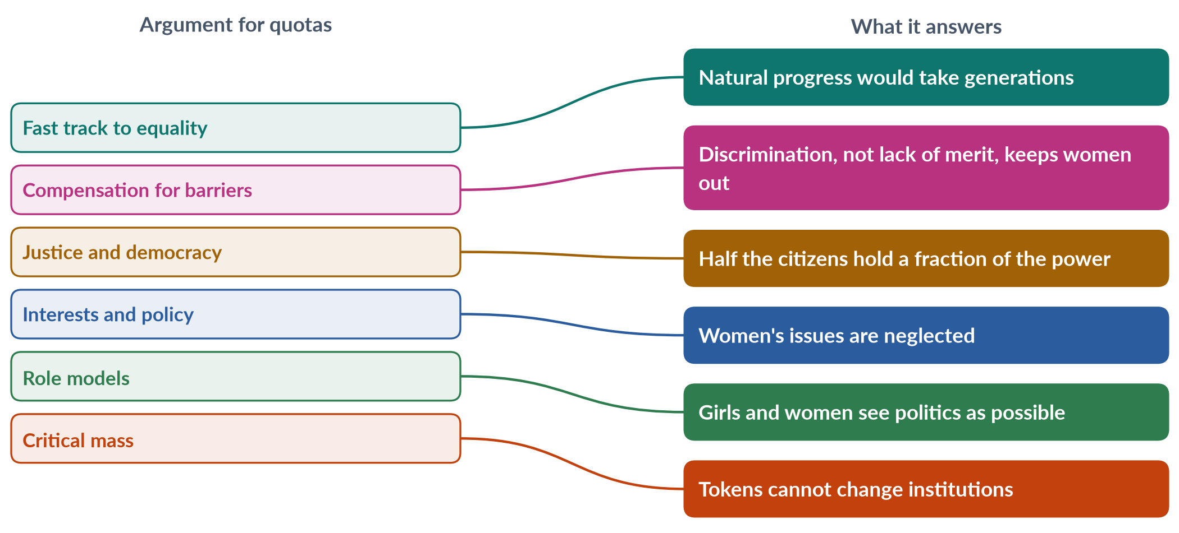
Figure 15 · Arguments for quotas and what each answers.
1. Fast track. Without quotas, women's representation grows very slowly. The Danish political scientist Drude Dahlerup contrasted the Nordic "incremental track" (decades of slow growth) with the "fast track" of quotas that jumps to a critical mass at once.
2. Compensation for barriers. Women do not lack ability; they face party gatekeeping, money, norms and violence. Quotas correct an unequal starting line, not merit.
3. Justice and democracy. A parliament should broadly reflect the people. Quotas give descriptive representation.
4. Better policy for women. Evidence from India and elsewhere shows that women representatives change spending priorities (Chapter 8).
5. Role models and norm change. Seeing women in office raises girls' aspirations and changes attitudes about who can lead.
6. Critical mass. Quotas create enough women to escape tokenism and form alliances, such as Pakistan's caucus.
7. Training ground. Local quotas give women experience that prepares them for higher office.

6.4 The case against quotas (cons)
1. Against merit. Critics say candidates should be chosen on ability alone, and quotas promote less qualified people.
2. Tokenism and proxies. Women may be chosen as proxies for male relatives ("biwi-beti-behen" — wife, daughter, sister — politics), especially where parties control lists.
3. Stigma. Quota women may be seen as "second-class" members who did not win "real" seats.
4. Ceiling, not floor. Parties may treat the quota as the maximum for women and stop giving them general tickets.
5. Elite capture. Seats go to educated, urban or dynastic women, not to poor or rural women.
6. Democratic objections. Reserved seats filled by party lists weaken the link between voters and representatives.
7. Essentialism. Quotas assume women share common interests, though women differ by class, party, religion and region.
8. Treating symptoms. Quotas do not remove the root causes — norms, money, violence.
BALANCED VIEW · QUOTAS — THE VERDICT
• For: quotas are the only proven way to raise women's representation quickly; they have changed the agenda in Pakistan, India, Nepal and Rwanda; "merit" in politics is already shaped by money and family.
• Against: quotas can produce tokens and proxies, stigmatise women, and become a ceiling.
➜ Line to take: quotas are necessary but not sufficient. Their design matters: direct election, winnable seats, sanctions for non-compliance, and support for women once elected turn presence into power.

6.5 Answering the "merit" objection
The merit objection is the most common, and examiners like to see it answered carefully.
- Merit is already distorted. In Pakistan, tickets go to "electables" with money, land and biradari — not to the most able. Men benefit from an unseen "quota" of family and networks.
- Women are not less qualified. Many reserved-seat women are highly educated professionals — doctors, lawyers, academics.
- Diversity improves decisions. Bodies with members of different experience consider a wider range of problems.
- The economist's view. Studies of Sweden's party quotas found that quotas pushed out mediocre men and raised the average competence of politicians (Besley and others, 2017).
IN SIMPLE WORDS
A quota does not lower the bar; it removes a hidden bar that was already there. If only men can pass through the gate, the gate itself is not measuring merit.

6.6 "Pulling each other up" — quotas beyond politics (2020)
The 2020 question asked whether women leaders should "pull each other up" or whether this is "inappropriate preferential treatment". This links quotas to leadership generally (Chapter 9). The arguments mirror those for quotas: women leaders can act as mentors, sponsors and role models, opening networks that men already enjoy; critics fear favouritism. The line to take: mentoring and sponsoring within fair, transparent procedures is not preferential treatment but the removal of barriers — the same thing men's networks have always done.

6.6a Political participation as a human right (2024)
The 2024 question asked: "Is political participation a human right?" The answer is clearly yes in international and Pakistani law.
✦ LAW & POLICY
The right to political participation · international and constitutional sources
• UDHR (1948), Article 21: everyone has the right to take part in the government of his country, directly or through freely chosen representatives.
• ICCPR (1966; ratified by Pakistan in 2010), Article 25: every citizen has the right to take part in public affairs, to vote and to be elected, without discrimination.
• CEDAW (1979; Pakistan 1996), Article 7: women's equal right to vote, stand for election, take part in policy-making and hold public office; Article 4(1): temporary special measures.
• Constitution of Pakistan: Article 17 (freedom of association and to form or join political parties), Article 25 (equality), Article 34 (full participation of women).

If participation is a right, then the state has a duty not only to allow women to vote and stand, but to remove barriers that prevent them — missing CNICs, agreements to bar women voters, violence, and party discrimination. This is the human-rights justification for quotas and for the 10% turnout rule: they are ways of making a formal right real. The UN Human Rights Committee's General Comment 25 (1996) on Article 25 makes the same point — states must take positive measures to overcome obstacles to participation.

6.7 Designing an effective quota — lessons from research
Table 6 · Quota design and its effects.
Design feature | Weak version | Strong version
Type | Voluntary or vague target | Legal requirement
Placement | Women at the bottom of lists or in losing seats | Zipper lists; winnable seats
Sanctions | None | Lists rejected; funding withheld
Selection | Leader picks relatives | Transparent, internal party elections
Election | Indirect (party lists only) | Direct election or rotation of constituencies
Duration | Temporary without review | Reviewed and extended until parity

EXAMINER'S EYE · THE MODEL STRUCTURE FOR 2016 AND 2021
Define quota and types → pros (fast track, barriers, justice, interests, role models, critical mass) → cons (merit, proxies, stigma, ceiling, elite capture) → Pakistan's experience (history; 60 seats; 5% tickets; caucus laws; but 11 general-seat women) → reforms → balanced conclusion. Use Dahlerup (fast track) and Pitkin (descriptive vs substantive).

Chapter 7 · The History and Evolution of Women's Quotas in Pakistan
"Elaborate the historical context and evolution of women's quota in Pakistan concerning key legislation and policies that have shaped the quota system" (2025). The 2021 question's "17 percent quota" refers to 60 of the 342 National Assembly seats created in 2002. MCQs asked for 60 seats (2024), 33% under devolution (2016), the paper's 17% (2016) and the two women of the first Constituent Assembly (2016, 2024).

7.1 The colonial roots
Reserved seats for women in the subcontinent began under British rule. The Government of India Act (1935) reserved seats for women in the federal and provincial legislatures and widened the women's franchise. Women such as Begum Jahanara Shahnawaz — who had attended the Round Table Conferences (1930–32) in London — won seats in the Punjab Assembly in 1937. Reserved seats thus came to Pakistan as part of its colonial inheritance.

7.2 The timeline
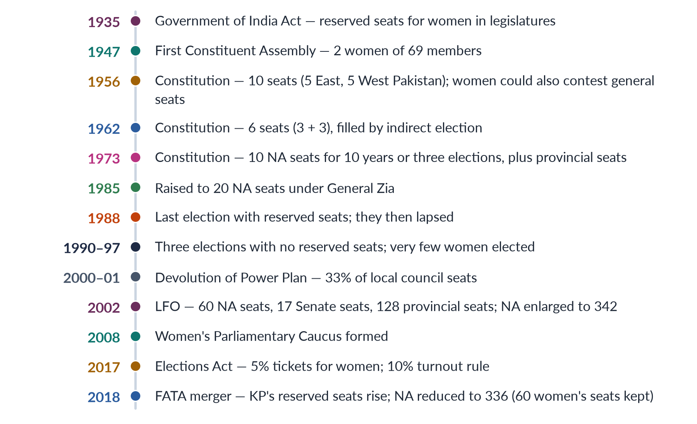
Figure 16 · The evolution of women's quotas in Pakistan.

7.3 Phase 1 — Early constitutions (1947–1971)
- The first Constituent Assembly (1947) had just two women among 69 members: Begum Jahanara Shahnawaz and Begum Shaista Suhrawardy Ikramullah. They pressed for the Muslim Personal Law (Shariat) Application Act to give women inheritance in agricultural land and for women's rights in the constitution.
- The 1956 Constitution reserved 10 seats for women in the unicameral National Assembly — five each from East and West Pakistan — for ten years. Women could also contest general seats.
- The 1962 Constitution of Ayub Khan reserved six seats (three from each wing), filled by indirect election through the Basic Democrats and assemblies.
Reserved seats in this phase were few and indirectly filled, and the members were mostly elite women from political families and the All Pakistan Women's Association (APWA).

7.4 Phase 2 — The 1973 Constitution and Zia (1973–1988)
The 1973 Constitution reserved 10 National Assembly seats for women (and a small number of provincial seats), for ten years or until the third general election, whichever came later. Members were elected indirectly by the assemblies.
Under General Zia-ul-Haq, the reserved seats were increased to 20 for the 1985 non-party election. Paradoxically, this came under a regime whose Hudood Ordinances (1979) and Law of Evidence (1984) harmed women's rights — and Zia's Majlis-e-Shoora included women appointees. Women members of this period were few and mostly unable to challenge these laws.

7.5 Phase 3 — The lapse (1988–2002)
The constitutional provision expired after the 1988 election, the third under the Constitution. In the elections of 1990, 1993 and 1997 there were no reserved seats, and only a handful of women — between two and six — won general seats. Ironically, this was the decade of Benazir Bhutto's two governments; she promised to restore the seats but neither her governments nor Nawaz Sharif's did so, partly because they lacked the two-thirds majority or the political will.
IN SIMPLE WORDS
The lapse is the clearest evidence for quotas in Pakistan: when the quota disappeared, women almost disappeared from parliament. With two to six women in a house of over 200, the National Assembly was over 97% male.

7.6 Phase 4 — Devolution and the 2002 quota

(1) Local government — 33% (2000–01)
General Pervez Musharraf's Devolution of Power Plan (2000) and the Local Government Ordinance (2001) reserved 33% of seats for women in union, tehsil and district councils (MCQ 2016). Around 36,000 women were elected as councillors in 2000–01 — the largest entry of women into politics in Pakistan's history. Many seats in conservative areas went unfilled, and some women were proxies for male relatives, but many gained experience and confidence.

(2) National and provincial — 60 seats (2002)
The Legal Framework Order (LFO) 2002, later validated by the 17th Amendment (2003), enlarged the National Assembly to 342 and reserved 60 seats for women — about 17.5% (the "17 percent quota" of the 2021 question and the 2016 MCQ). It reserved 17 seats in the Senate and 128 in the provincial assemblies. The seats are filled by proportional representation from party lists, in proportion to the general seats each party wins.
The National Commission on the Status of Women (2000) and the National Policy for Development and Empowerment of Women (2002) — which called for women's representation in decision-making — formed part of the same policy package. The impact was immediate: women's share of the National Assembly rose from under 3% to over 20% in 2002.

7.6a How reserved seats are allocated — a worked example
The women's seats in the National Assembly are divided among the provinces (after the 2023 census delimitation: Punjab 32, Sindh 14, Khyber Pakhtunkhwa 10, Balochistan 4). Within each province, parties receive women's seats in proportion to the general seats they win there, under Article 51(6)(d); independents who join a party within three days of the results are counted with that party.
IN SIMPLE WORDS
Suppose a party wins half of Punjab's general seats. It receives about half of Punjab's 32 women's seats — 16 — and fills them from the top of the priority list it submitted before the election. A party that wins no general seats gets no reserved seats, however many votes it received.

This system explains two features of Pakistani politics: reserved-seat women are loyal to party leaders, who decide list order, and the seats become a prize in disputes over party membership — as in the 2024–25 dispute over PTI-backed independents.

7.7 Phase 5 — Consolidation and new reforms (2008 onwards)
- The 18th Amendment (2010) retained the reserved seats and Article 34.
- The Women's Parliamentary Caucus (2008) turned numbers into laws (Chapter 5).
- Provincial local government laws (from 2013) kept women's seats, but most cut the share below the 2001 level of 33%.
- The Elections Act 2017 introduced the first candidate quota (5% of general-seat tickets, Section 206), the 10% women's turnout rule (Section 9), and special measures for registration where the gender gap exceeds 10%.
- The 25th Amendment (2018) merged the tribal areas into Khyber Pakhtunkhwa; the National Assembly was reduced to 336 seats, but the 60 women's seats were kept, and KP's reserved provincial seats rose.

7.7a Reform proposals in the debate
Women legislators, the NCSW and civil-society groups have put forward several proposals for the next stage of the quota's evolution:
1. Raise the share of reserved seats towards 33%, in line with the Beijing target and the 2001 local-government quota.
2. Direct election of women's seats — through rotating reserved constituencies or dual-member constituencies — so that women have voters and a power base of their own.
3. Strengthen Section 206 of the Elections Act 2017: raise the candidate quota from 5% and require that women be fielded in winnable seats, with sanctions for non-compliance.
4. Restore and protect local quotas of at least 33% in every province's local-government law.
5. Transparent party lists, chosen through internal party elections rather than by leaders alone.
These proposals respond directly to the weaknesses of the present system — indirect election, party dependence and the "ceiling" effect — and give you a ready-made way forward for questions on quotas (2016, 2021, 2024, 2025).

7.8 Assessing the evolution
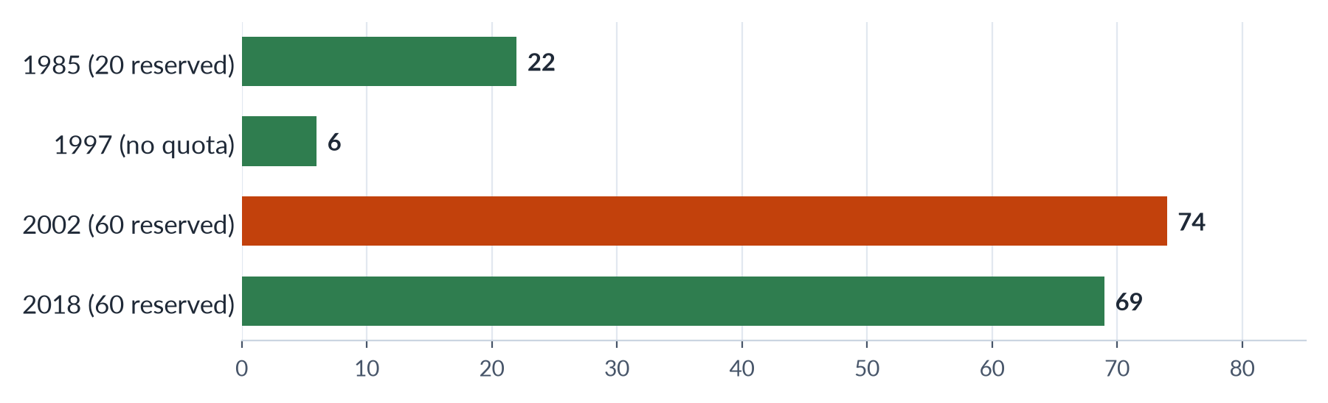
Figure 17 · Women in the National Assembly under different quota regimes (approximate number of women members).
BALANCED VIEW · HAS THE QUOTA SYSTEM EVOLVED IN THE RIGHT DIRECTION?
• Gains: a permanent, larger quota since 2002; a candidate quota since 2017; legal protection of women's votes; women's representation at about one-fifth; laws for women passed by women.
• Gaps: seats still filled indirectly by party leaders; the 5% ticket rule is weak; few women win general seats (11 in 2024); local quotas reduced; the quota has become a ceiling in party minds.
➜ Line to take: Pakistan's quota has moved from symbolic (1956–88) to substantial (since 2002), but not yet to empowering. The next step is direct election and stronger candidate quotas.

EXAMINER'S EYE · THE MODEL STRUCTURE FOR 2025
1. Introduction: quota defined; Pakistan's mix of reserved seats and candidate quota. 2. Colonial roots (1935). 3. Early constitutions (1956: 10; 1962: 6). 4. 1973 and Zia (10 → 20). 5. The lapse (1988–2002) and its lesson. 6. Devolution (33%) and the LFO (60, 17, 128). 7. 2008–2017 (caucus, 18th Amendment, Elections Act: 5% and 10%). 8. Assessment. 9. Reforms. 10. Conclusion. Draw the timeline.

Chapter 8 · The Impact of Women Representatives: Do Women Make a Difference?
The syllabus names "impact of women representatives on politics". The 2017 question quoted: "Women's active political participation could stabilise democracy and boost economic development." The 2018 question asked whether we need equal numbers of women in politics ("women cover half the sky"), and the 2021 question asked whether the quota is "showing results".

8.1 How to measure impact
"Impact" can mean several things. A good answer separates them:
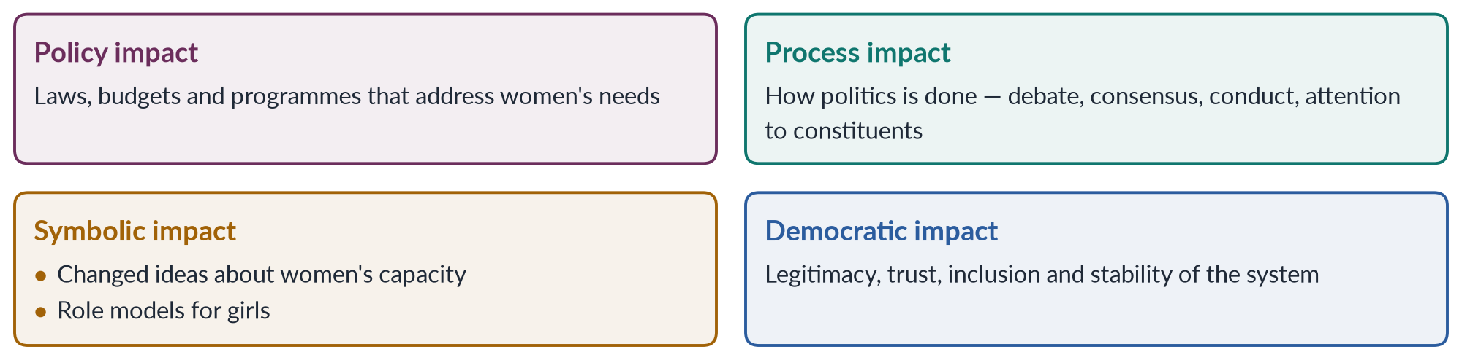
Figure 18 · Four kinds of impact women representatives can have.

8.2 Evidence from around the world
✦ CASE
Women leaders in Indian village councils · Chattopadhyay and Duflo (2004)
India's 1992 constitutional amendments reserved one-third of village council (panchayat) headships for women, chosen at random — a natural experiment. Economists Raghabendra Chattopadhyay and Esther Duflo studied villages in West Bengal and Rajasthan and found that women leaders invested more in public goods that women had asked for — especially drinking water — and in roads in West Bengal, where women had requested them.
➜ Strong evidence that who governs changes what is provided.

✦ CASE
Role models in India · Beaman and colleagues (2009, 2012)
Later studies in West Bengal found that after villages had women leaders, voters' bias against women leaders fell, and parents' aspirations for their daughters — and girls' own aspirations for education and careers — rose.
➜ The symbolic impact of women in office is measurable.

Other studies have linked more women legislators to greater attention to health, education, childcare and violence against women, and to lower tolerance of corruption in some contexts — although the evidence on corruption is mixed and depends on the political system.

8.3 Evidence from Pakistan

(1) Laws for women
The clearest evidence of impact is the series of laws passed after 2002, many proposed or pushed by women legislators and the Women's Parliamentary Caucus:
Table 7 · Pro-women laws passed after the 2002 quota.
Year | Law | Role of women legislators
2006 | Protection of Women (Criminal Laws Amendment) Act | Debated in an assembly with 60+ women members
2010 | Protection against Harassment of Women at the Workplace Act; s. 509 PPC | Caucus and women members drove it
2011 | Acid Control and Acid Crime Prevention Act | Private member's bill by women MNAs
2011 | Prevention of Anti-Women Practices Act | Private member's bill by women MNAs
2012 | National Commission on the Status of Women Act | Caucus priority
2016 | Anti-honour-killing and anti-rape laws | Pushed by women senators and MNAs after Qandeel Baloch
2013–2021 | Provincial domestic-violence laws (Sindh, Balochistan, Punjab, KP) | Women members in provincial caucuses

(2) Parliamentary activity
Monitoring by FAFEN and PILDAT has repeatedly found women legislators — though only about one-fifth of members — among the most active in moving questions, calling-attention notices, resolutions and private members' bills, and with good attendance.

(3) Agenda change
Issues once treated as "private" — domestic violence, harassment, acid attacks, honour killings, inheritance — have become regular business of the assemblies. Women members have also raised health, education and social protection — the Benazir Income Support Programme (2008), paid to women, was championed by women in the PPP government.

(4) Local government
Studies of the women councillors of 2001–2005 found mixed results. Many were proxies, and male councillors often excluded them from development funds. But many others raised women's concerns — water, girls' schools, health — and gained confidence and respect; some moved on to provincial politics.

8.3a A case: how the 2016 honour-killing law was passed
The story of the anti-honour-killing law shows women legislators as critical actors. Senator Sughra Imam moved an anti-honour-killing bill in 2014; the Senate passed it in 2015, but it stalled in the National Assembly. After the social-media celebrity Qandeel Baloch was murdered by her brother in July 2016, women legislators, the caucus, civil society and the media pressed again. A joint sitting of Parliament passed the Criminal Law (Amendment) (Offences in the name or pretext of Honour) Act in October 2016, making a life sentence mandatory even if the family forgives the killer. The law did not end honour killings, but it closed the "forgiveness" loophole that had let many killers go free.

8.4 Women, democracy and development (2017)

(1) Stabilising democracy
- Legitimacy: a parliament that includes women is more representative and more trusted.
- Peace and consensus: research on peace processes (linked to UN Security Council Resolution 1325, 2000) suggests agreements are more durable when women take part. Women legislators in Pakistan have often worked across party lines — the caucus is one of the few cross-party bodies in a polarised parliament.
- Inclusion: bringing half the population into politics widens the base of democracy and reduces alienation.

(2) Boosting economic development
- Better spending: women representatives tend to favour health, education, water and nutrition — investments with high returns (the Chattopadhyay–Duflo evidence).
- Women's economic rights: laws on harassment, property (2020), home-based workers (Sindh 2018) and maternity leave help women enter and stay in work — and raising female labour-force participation from 24.4% would add greatly to GDP.
- Human capital: girls' education and maternal health, often championed by women, raise productivity in the next generation.
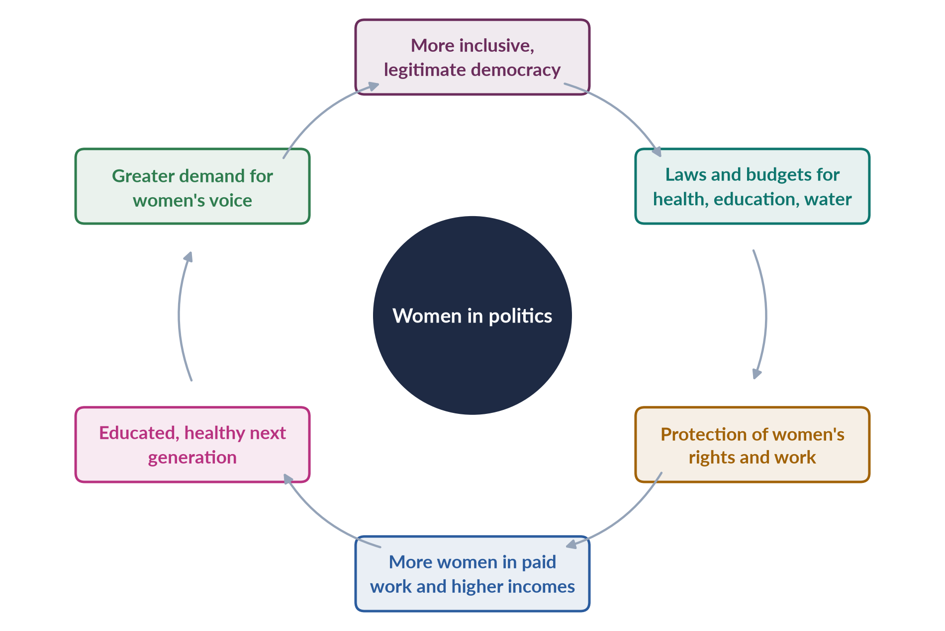
Figure 19 · How women's political participation can strengthen democracy and development.

(3) Within Pakistan's socio-economic realities
The 2017 question asked you to comment "within the context of the socio-economic realities of Pakistani society". The realities that limit this potential are: poverty and low literacy; patriarchal norms; feudal and tribal power; dynastic politics; military interventions that interrupted democracy; and women legislators' dependence on party leaders. A balanced answer accepts the statement's logic but shows that women's participation can stabilise democracy and boost development only if it is real — independent, resourced and supported.

8.5 Do we need equal numbers? (2018)
The Chinese saying "women hold up half the sky" (associated with Mao Zedong) expresses the idea that women are equal contributors to society.
BALANCED VIEW · EQUAL NUMBERS OF WOMEN IN ALL PUBLIC SPHERES?
• For parity: justice — half the citizens should hold half the power; descriptive representation; women's distinct interests; evidence of policy impact; parity laws in France (2000) and many Latin American countries, and Rwanda's majority-women parliament, show it can be done.
• Against rigid parity: individuals should be chosen on merit and choice; women are not one group with one interest; forced parity may produce proxies; some women may not wish to enter politics because of care duties.
• A middle view: aim at parity of opportunity and remove barriers; use quotas as a means towards a critical mass (30%) and eventually parity; judge success by outcomes, not numbers alone.
➜ Line to take: the goal of equal participation is right — and is the logic of CEDAW and SDG target 5.5 — but numbers must come with real power and independence.

8.6 Limits of impact — why presence does not always mean power
1. Party discipline — members vote with the party; women's issues compete with party priorities.
2. Dependence — reserved-seat women owe their seats to leaders.
3. Elite composition — many women legislators are from privileged families and may not represent poor women.
4. Marginal posts — few women control finance, interior or planning.
5. Implementation gap — laws passed are poorly enforced (Topic 5).
6. Backlash — conservative members and bodies such as the Council of Islamic Ideology have opposed some laws (the Punjab violence law of 2016).

8.6a How to measure substantive representation
Saying that women "make a difference" needs evidence. Researchers measure substantive representation in several ways, and you can use these indicators in any answer:
1. Legislation: bills introduced and passed on issues affecting women — in Pakistan, the 2010–2016 laws.
2. Parliamentary activity: questions, calling-attention notices, resolutions and debate time on women's issues — FAFEN and PILDAT publish such data.
3. Committee work: women chairing or shaping committees on human rights, health, education and finance.
4. Budgets: whether spending on health, education, water and social protection rises when more women hold office.
5. Oversight: whether women legislators hold governments to account for implementing laws.
6. Attitudes: surveys showing whether citizens' views of women leaders change (India's role-model studies).
Table 8 · Indicators of women's substantive impact, with Pakistani examples.
Indicator | Pakistani example
Laws passed | Harassment 2010; acid and anti-women practices 2011; NCSW 2012; honour killing 2016
Private members' bills | Women MNAs moved the acid and anti-women practices bills (2011)
Cross-party work | Women's Parliamentary Caucus (2008)
Social spending | BISP (2008), paid to women
Agenda-setting | Domestic violence, inheritance and harassment debated as public issues

EXAMINER'S EYE · USING THIS CHAPTER
For "Is the quota showing results?" (2021), show impact in four areas (policy, process, symbolic, democratic) with Pakistani evidence (the laws table; the caucus; activity data), then the limits, then reforms. For 2017, use the cycle figure and the socio-economic realities.

Chapter 9 · Women in Leadership: Glass Ceilings, Glass Cliffs and "Pulling Each Other Up"
"Women need to be in leadership positions to pull more women into leadership roles. Is this suggestion that women need to 'pull each other up' useful, or is it inappropriate preferential treatment?" (2020). A 2026 MCQ asked the meaning of the "glass cliff".

9.1 Leadership — the top rung
Leadership means holding positions of authority — heads of government, ministers, party leaders, judges, senior civil servants, chief executives. Women are scarcer here than anywhere else. Worldwide, only a few dozen countries have a woman head of state or government at any time, and women hold a minority of cabinet posts and senior management roles.
✦ DATA
Women in leadership in Pakistan
Benazir Bhutto (prime minister 1988–90, 1993–96); Maryam Nawaz (first woman chief minister, Punjab, 2024); Justice Ayesha Malik (first woman Supreme Court judge, 2022); Fahmida Mirza (first woman Speaker, 2008); Hina Rabbani Khar (first woman foreign minister, 2011); Tehmina Janjua (first woman foreign secretary, 2017). But in 2025 there were no women federal ministers, and women hold few senior posts in the civil service, police, business and universities.

9.2 The metaphors of women's leadership
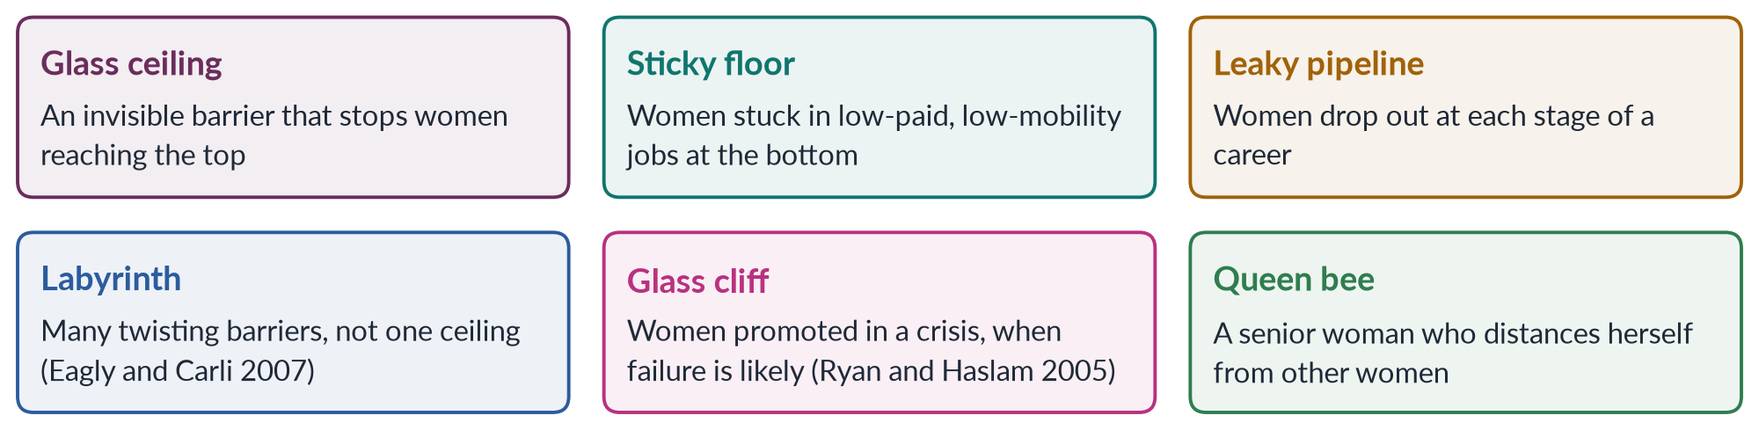
Figure 20 · Metaphors for the barriers women face on the way to leadership.
1. Glass ceiling — the term became popular in the 1980s in the United States for invisible barriers — prejudice, networks, stereotypes — that keep women from the top.
2. Sticky floor — many women never leave low-paid, low-status jobs.
3. Leaky pipeline — women are equal or majority at entry (e.g. medicine and law graduates in Pakistan) but fall away at each promotion.
4. Labyrinth — Alice Eagly and Linda Carli (2007) argued that women face a maze of barriers throughout their careers, not just one at the top.
5. Glass cliff — Michelle Ryan and Alex Haslam (2005) found that women in the UK were more often appointed to company boards after a period of poor performance — given leadership when the risk of failure was high. In politics, women are sometimes chosen to lead parties or governments in crisis.
6. Queen bee — a term coined by Staines, Tavris and Jayaratne (1974) for senior women who, having succeeded in a male world, distance themselves from junior women or deny that discrimination exists. Later research links this to the pressures of working in male-dominated cultures rather than to women's character.

9.3 Why women are scarce in leadership
1. Stereotypes: leadership is associated with "masculine" traits — assertiveness, toughness — so women are judged less suitable; when women show those traits, they are disliked (the "double bind").
2. Networks: men benefit from informal networks — the "old boys' club" — that provide information, mentors and sponsors.
3. Care responsibilities: women carry most care work; long hours and travel penalise mothers.
4. Selection procedures: promotion depends on subjective judgements and informal sponsorship.
5. Harassment and hostile cultures push women out.
6. Few role models: with few women at the top, young women find it harder to imagine themselves there.

9.3a Women leaders and the double bind in Pakistan
Women leaders in Pakistan face a sharp version of the double bind. If they are tough, they are called arrogant or "unwomanly"; if they are gentle, they are called weak. Their clothing, family life and marital status draw comment that male leaders escape. Benazir Bhutto faced opponents who argued that a woman could not head a Muslim state; Maryam Nawaz's appointment drew similar comment. Women in the bureaucracy and judiciary report that they must work harder to be taken seriously. Yet these leaders' performance has shown that leadership is not a male trait — which is exactly the symbolic impact the theory predicts.

9.4 "Pulling each other up" — the case for (2020)
The idea that women leaders should help other women rise has several forms:
- Role models — simply by being visible, women leaders show that leadership is possible.
- Mentoring — advising and encouraging younger women.
- Sponsorship — actively recommending women for posts and opportunities (sponsorship has been found to matter more than mentoring for promotion).
- Networks — women's associations, caucuses and professional groups.
- Policy — women leaders adopting family-friendly policies, anti-harassment rules and fair procedures.
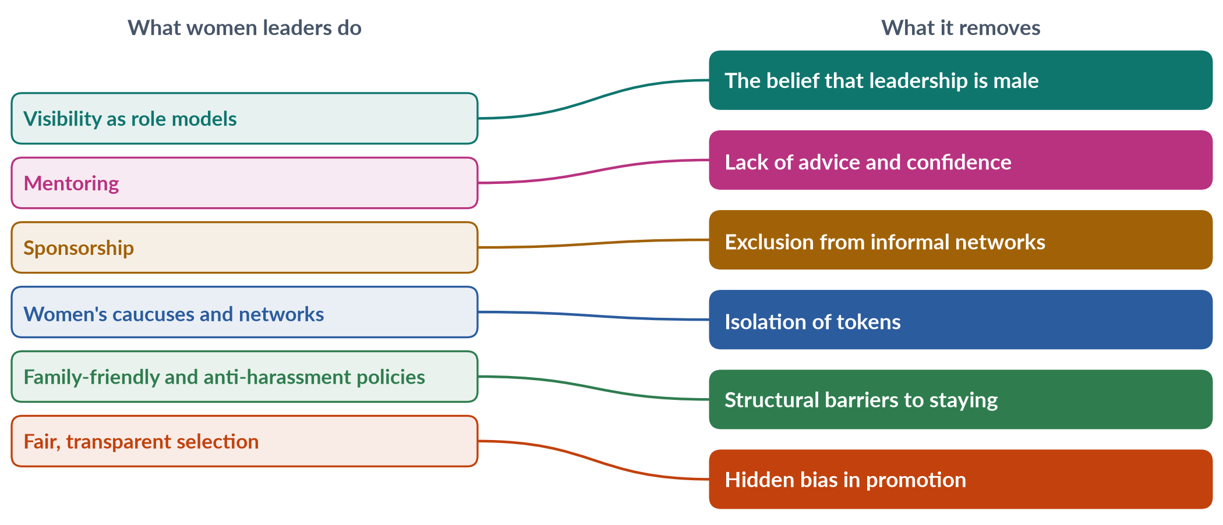
Figure 21 · How women leaders can "pull each other up".
Arguments that it is useful:
1. It mirrors what men have always done through informal networks; it levels the field rather than tilting it.
2. It reduces tokenism: a lone woman is isolated; several women can support each other (Kanter).
3. It builds a pipeline of qualified women.
4. Evidence shows women leaders can raise the aspirations of girls and women (the Indian role-model studies).
5. Pakistan's Women's Parliamentary Caucus is an example: women across parties supported one another and passed laws.

9.5 "Inappropriate preferential treatment" — the case against
1. Merit: helping someone because she is a woman may bypass more able candidates.
2. Resentment and stigma: colleagues may assume women rose through favour, undermining all women.
3. Burden: expecting women leaders to "lift" others places an extra duty on them that men do not carry.
4. Assumes solidarity: women differ by class, party and ideology; a woman leader is not obliged to favour women.
5. The queen bee reality: some women leaders do not help others, so the idea may be unrealistic.

9.6 The line to take
BALANCED VIEW · USEFUL OR PREFERENTIAL?
• Useful when it means mentoring, sponsoring, networking, role modelling and making institutions fair — removing barriers within transparent, merit-based procedures.
• Inappropriate if it means appointing women only because they are women, without regard to ability, or excluding men unfairly.
➜ Line to take: "pulling each other up" is not preferential treatment but corrective action that replaces the hidden preference men already enjoy. It works best together with institutional reforms — quotas where needed, fair recruitment, childcare and anti-harassment policies — so that women's advancement does not depend on the goodwill of a few.

IN SIMPLE WORDS
Imagine climbing a wall where men have ropes handed down from those already at the top, and women have none. A woman who reaches the top and lowers a rope is not cheating — she is giving others what men already had.

9.7 Women in other governance roles in Pakistan
- Civil service: a 10% quota for women in federal government jobs; women pass the CSS examination in growing numbers and have entered groups such as the Police Service and the Foreign Service, but few reach the highest grades.
- Police: women's police stations since 1994; women remain a tiny share of police personnel.
- Judiciary: women are a growing share of civil judges at entry level, but few sit in high courts and the Supreme Court.
- Business: the Securities and Exchange Commission requires listed companies to have at least one woman director.
- Armed forces: women serve as doctors and in some combat roles; Lt Gen Nigar Johar became the first woman lieutenant general in 2020.

9.7a Women in Pakistan's civil service
The bureaucracy is where most government decisions are carried out, so women's presence in it matters as much as in parliament.
- Entry: a 10% quota for women applies in federal government jobs, and women compete on merit in the CSS examination, where their numbers have grown steadily; many now join groups once seen as male preserves, such as the Police Service, the Pakistan Administrative Service and the Foreign Service.
- Progress: women have served as federal secretaries, ambassadors, a foreign secretary (Tehmina Janjua, 2017) and senior police officers.
- Barriers: postings to remote districts, long hours and transfers clash with family expectations; harassment and male-dominated cultures persist; and few women reach the top grades, so the pipeline still leaks.
- Policy: day-care facilities in offices, transparent postings and promotions, enforcement of the harassment law, mentoring networks for women officers, and flexible arrangements for officers with young children.
Women in the bureaucracy also improve service delivery for women citizens — a woman assistant commissioner or police officer may be more approachable for women complainants, which links leadership directly to governance outcomes.
EXAMINER'S EYE · THE MODEL STRUCTURE FOR 2020
1. Introduction: leadership gap; the suggestion explained. 2. Barriers (glass ceiling, labyrinth, networks, stereotypes, care). 3. The case for "pulling up" (role models, mentoring, sponsorship, networks, tokenism; India; the caucus). 4. The case against (merit, stigma, burden, solidarity assumed, queen bee). 5. Pakistan's women leaders and their record. 6. Line to take: corrective, not preferential — with institutional reform. 7. Conclusion. Draw the mapping figure.

Chapter 10 · Case Studies: Women and Governance in South Asia
The syllabus names "case studies of Sri Lanka, Pakistan, India, Bangladesh and Nepal". No full question has yet been a pure case study, but comparisons strengthen every Topic 6 answer: Nepal's 33%, India's panchayats, Bangladesh's 50 seats and Sri Lanka's first woman prime minister are the evidence that design matters.

10.1 The South Asian paradox
South Asia has produced more women heads of government than almost any other region — Sirimavo Bandaranaike, Indira Gandhi, Benazir Bhutto, Khaleda Zia, Sheikh Hasina, Chandrika Kumaratunga — yet ordinary women's political participation remains low. Most of these leaders came from political dynasties: daughters or widows of assassinated or famous leaders. Their rise showed that women can lead, but it did not open politics to women in general.
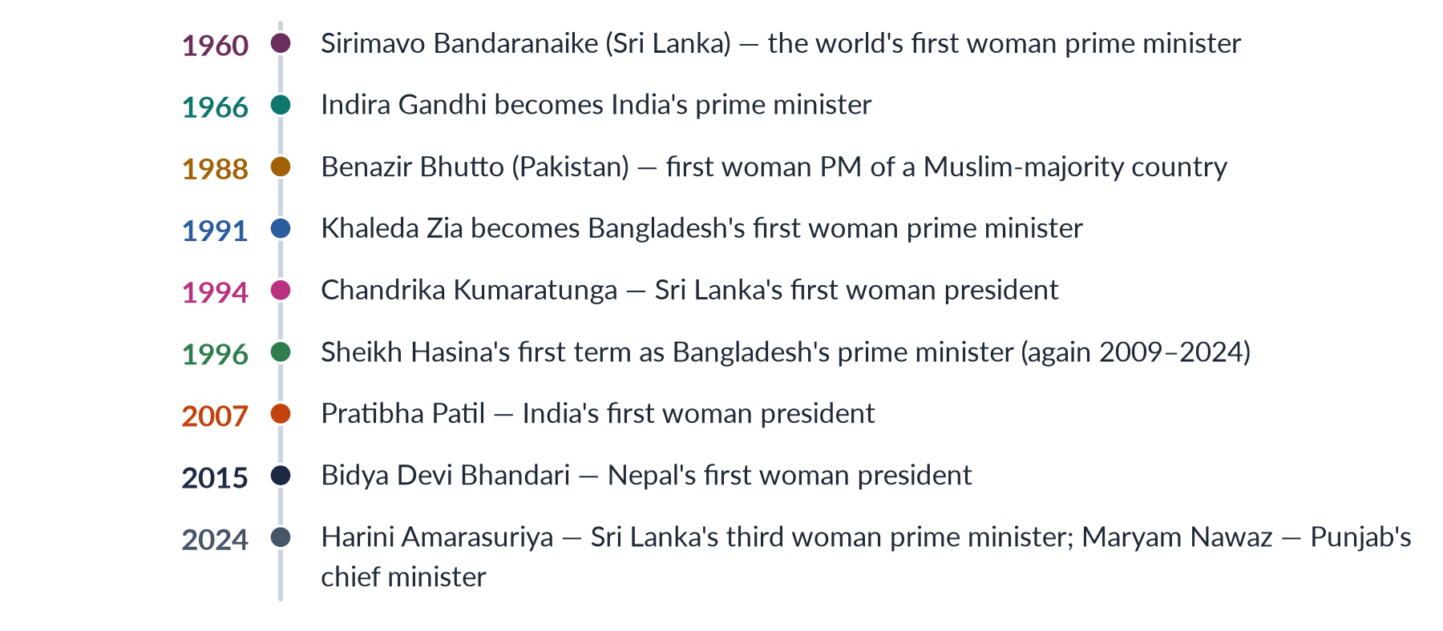
Figure 22 · Women heads of government and state in South Asia — selected firsts.

10.2 India
- Suffrage: women voted on equal terms from the first elections under the 1950 Constitution.
- Local quotas: the 73rd and 74th Amendments (1992) reserved one-third of seats and headships in panchayats and municipalities for women; many states have raised this to 50%. More than a million women have been elected to local bodies.
- Parliament: women held about 14% of the Lok Sabha after the 2024 election (74 women).
- The Women's Reservation Act: after decades of failed bills (first introduced in 1996), Parliament passed the Constitution (106th Amendment) Act, 2023 (Nari Shakti Vandan Adhiniyam), reserving one-third of seats in the Lok Sabha and state assemblies for women for 15 years. It will operate only after the next census and delimitation — not before 2029.
- Lessons: rotating reserved constituencies allow direct election of women; local quotas produced evidence of policy impact (Chattopadhyay and Duflo); but "sarpanch-pati" (husband of the woman head) proxies are a known problem.

10.3 Bangladesh
- Leadership: two women — Khaleda Zia (BNP) and Sheikh Hasina (Awami League) — alternated as prime minister for most years from 1991 to 2024. Hasina's government fell in August 2024 after mass student-led protests.
- Reserved seats: 15 seats in 1972, 30 in 1979, a lapse in the early 2000s, 45 in 2004 and 50 since 2011, filled by parties in proportion to their seats — similar to Pakistan.
- 2026 election: of 85 women candidates, only 7 were directly elected; with the 50 reserved seats, women held 57 of 350 seats.
- Local government: since 1997 three seats in each Union Parishad are reserved for women and directly elected, bringing tens of thousands of women into local politics.
- Lessons: women at the top did not translate into women on general seats; indirect reserved seats share Pakistan's weaknesses; directly elected local seats work better.

10.4 Sri Lanka
- Suffrage: universal adult franchise in 1931 under the Donoughmore Constitution — among the first in Asia.
- Leadership: Sirimavo Bandaranaike (1960), the world's first woman prime minister, after her husband's assassination; her daughter Chandrika Kumaratunga, president (1994–2005); Harini Amarasuriya, prime minister from 2024.
- Parliament: despite high female literacy, women held only about 5% of seats for decades. A record 22 women entered the 225-member parliament in 2024.
- Local quota: a 25% quota for women in local councils, first applied in 2018, raised women's local representation from about 2% to over 20%.
- Lessons: education alone does not produce representation; quotas brought the leap.

10.5 Nepal
- Constitution 2015: requires that at least one-third of members of the federal parliament be women, and that the president and vice-president be of different sexes or communities; in each local body the head or deputy must include a woman, and wards must include women and Dalit women.
- Mixed electoral system: first-past-the-post seats plus proportional representation lists. Parties meet the 33% mainly through PR lists, where women are more than half of nominees.
- 2026 election: women won 96 of 275 House seats (about 35%) — but only 14 through FPTP.
- Local level: the 2017 local elections brought over 14,000 women into office, about 41% of local representatives, many of them Dalit women.
- Leadership: Bidya Devi Bhandari became the first woman president (2015); Sushila Karki, a former chief justice, became the first woman (interim) prime minister in 2025.
- Lessons: constitutional quotas with PR lists and intersectional rules (Dalit women) produce the region's highest representation; but women rarely win direct seats and are often deputies rather than heads.

10.5a Pakistan as a case study
The syllabus lists Pakistan among the case studies. In one paragraph, Pakistan's story is this:
- Firsts at the top: Fatima Jinnah challenged a military ruler in 1965; Benazir Bhutto became the first woman prime minister of a Muslim-majority country (1988); Maryam Nawaz became Punjab's chief minister (2024).
- A quota that came and went: 10 seats (1956), 6 (1962), 10 (1973), 20 (1985), none in the 1990s, then 60 seats and 33% local seats under Musharraf (2000–02).
- Laws made by women: the Women's Parliamentary Caucus (2008) and the pro-women laws of 2010–2016.
- Persistent gaps: a voter registration gap of 9.94 million, turnout of 43% against 52%, only 11 women on general National Assembly seats (2024), no women federal ministers (2025), and women legislators dependent on party leaders.
Compared with its neighbours, Pakistan sits in the middle: ahead of India and Sri Lanka in women's share of parliament, behind Nepal, and similar to Bangladesh in relying on indirectly filled reserved seats.

10.6 Pakistan in comparison
Table 9 · Women and governance in South Asia compared.
Country | National quota | Women in lower house (latest) | Distinctive feature
Pakistan | 60 reserved seats (2002); 5% tickets (2017) | About one-fifth | Indirect reserved seats; 10% turnout rule
India | One-third (2023 Act, from about 2029) | About 14% (2024) | One-third local quota since 1992, directly elected
Bangladesh | 50 reserved seats (2011) | 57 of 350 (2026) | Two women PMs for three decades
Sri Lanka | No national quota; 25% local quota | 22 of 225 (2024) | World's first woman PM (1960)
Nepal | One-third by constitution (2015) | 96 of 275 (2026) | PR lists; Dalit women's seats locally

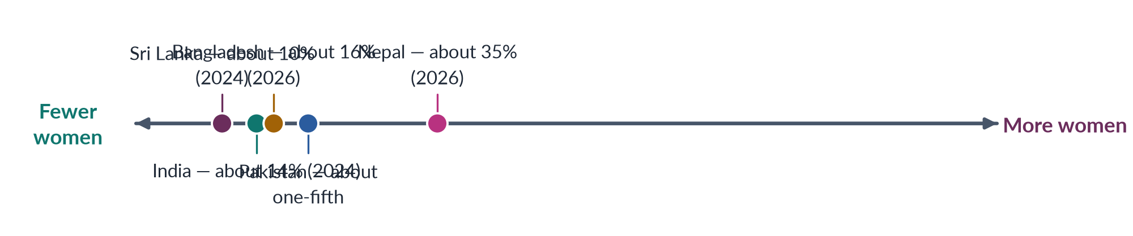
Figure 23 · South Asian countries by women's share of the lower house (approximate).

10.6a Common challenges across South Asia
Despite their different systems, the five countries share common problems:
1. Dynastic politics — women at the top mostly from political families.
2. Party gatekeeping — parties give women few winnable general seats; women win far more often through lists or reserved seats than directly (Nepal: only 14 FPTP winners in 2026; Bangladesh: 7).
3. Money and violence — costly campaigns and violence against women in politics.
4. Proxy representation — "sarpanch-pati" in India, male relatives speaking for women councillors in Pakistan and Bangladesh.
5. Social norms — purdah, honour and care burdens restrict women's mobility and public roles.
6. A local–national gap — women are numerous in local bodies but scarce in national cabinets and party leaderships.
The region shows that quotas get women into office, but party reform, money, safety and social change decide whether they gain real power.

10.7 Lessons for Pakistan
1. Design matters more than culture. Nepal, with a similar social structure, reaches 35% through constitutional quotas and PR lists.
2. Direct election of women (India's rotating seats, Bangladesh's Union Parishad seats) gives women constituencies and legitimacy.
3. Local quotas are a training ground (India, Nepal, Sri Lanka, Pakistan in 2001).
4. Intersectional quotas (Nepal's Dalit women) bring in the most marginalised.
5. Dynastic women leaders do not, by themselves, open politics to ordinary women.
6. Enforcement — quotas need sanctions and monitoring.
EXAMINER'S EYE · USING THE CASE STUDIES
In any quota answer, add one comparative paragraph: "Nepal's constitutional one-third with PR lists produced 35% women in 2026; India's panchayat quota showed that women leaders change spending; Bangladesh shows that women at the top do not guarantee women on general seats." Three sentences, three countries — examiners reward it.

Part Two — Today's Debates
Topic 6 questions are almost all debates: quotas for or against, results or no results, preference or fairness. Each debate below gives you facts, both sides and a line to take.

Debate 1 · Reserved seats: direct or indirect election?
Pakistan's 60 women's seats are filled from party lists, not by voters.
- For indirect seats: they guarantee women's presence; they bring educated professionals who might never win a constituency; they are simple to administer.
- For direct election: women would have constituencies, voters and legitimacy; they would be less dependent on party leaders; it would end the "nominated" stigma. Options include rotating reserved constituencies (as in India's panchayats) or dual-member constituencies with one woman member.
- Line to take: move gradually to direct election — the main weakness of Pakistan's quota is that it gives presence without a power base.

Debate 2 · Is the 5% ticket rule meaningful?
The Elections Act 2017 requires parties to give 5% of general-seat tickets to women.
- Supporters: it is the first candidate quota; more women contested in 2018 and 2024; 11 women won general seats in 2024.
- Critics: 5% is tiny; parties place women in losing seats; there are no real sanctions.
- Line to take: raise it (to at least 10–33%), require women in winnable seats, and attach sanctions.

Debate 3 · Has the quota become a ceiling?
Since 2002, parties have tended to treat reserved seats as women's "share" and give men nearly all general tickets.
- Line to take: the quota should be a floor; candidate quotas and party reform are needed so that women compete for general seats too.

Debate 4 · Dynastic women — empowerment or proxy?
Many women leaders — Benazir Bhutto, Maryam Nawaz, and many reserved-seat members — come from political families.
- Empowerment view: dynasties gave women a route into a closed system; many became leaders in their own right.
- Proxy view: dynasty keeps power in elite families and excludes ordinary women.
- Line to take: dynasty is a route, not a disqualification; the problem is the lack of other routes.

Debate 5 · Do women representatives represent "women"?
Women differ by class, region, religion and party.
- Line to take: women legislators have united on violence and rights (the 2010–2016 laws), but poor, rural and minority women remain under-represented — an intersectional gap (Topic 5).

Debate 6 · Should political participation be treated as a human right? (2024)
- Yes: UDHR Article 21 (1948), ICCPR Article 25 (1966), CEDAW Article 7 (1979) and Pakistan's Articles 17, 25 and 34 protect the right to vote, stand and take part in public affairs.
- What follows: if participation is a right, the state must remove barriers — registration, violence, party discrimination — not just allow women to try.
- Line to take: participation is a human right; quotas and protective measures are ways of making it real.

Debate 7 · After the 2025 "zero women ministers"
The Global Gender Gap Report 2025 recorded no women in Pakistan's federal cabinet; the 2026 report showed political empowerment up 11 places (to 107th).
- Line to take: appointing women to cabinet is the quickest, cheapest way to raise women's political empowerment — but appointments can be reversed; elected women on general seats are more durable.

Part Three — The Examiner's Record of Topic 6

Every question, 2016–2026
Table 10 · Every question the examiner has set on T6, 2016–2026.
Year · Q | The question (as set) | Family
2016 · Q4 | What are the pros and cons of gender quota in politics? Give your views on the impact of gender quota in politics in Pakistan. | Political quotas for women
2017 · Q4 | 'Women's active political participation could stabilize democracy and boost economic development.' Comment on this statement within the context of the socio-economic realities of Pakistani society. | Women's political participation
2018 · Q7 | Believing in the statement that 'women cover half the sky', do you think we need an equal number of women in all spheres of the public domain, especially in politics? | Women's political participation
2019 · Q8(a) | Short note: Suffragist movement | The suffragist movement
2020 · Q5 | Women need to be in leadership positions to pull more women into leadership roles. Is this suggestion that women need to 'pull each other up' useful, or is it inappropriate preferential treatment? | Women in leadership
2021 · Q8 | Despite the entry of women legislators into politics on a 17 percent quota in national and provincial assemblies, there are still voices asking, 'Is Pakistan's gender quota in parliament showing results?' Rethink and discuss how quotas can lead to the political mainstreaming of women in Pakistan. | Political quotas for women
2022 · Q5 | In your opinion, what are the main issues faced by women as representatives in Pakistan? | Women as representatives / politicians
2024 · Q7 | Is political participation a human right? If so, what obstacles are faced by women politicians in Pakistan in pursuing a career in politics? What is the impact of the political quota system on this? | Women's political participation; Political quotas for women
2025 · Q5 | Elaborate the historical context and evolution of women's quota in Pakistan concerning key legislation and policies that have shaped the quota system. | Political quotas for women

What the record reveals
- Eight full questions and one short note (8.5 visits), and 14 of the 140 MCQs — mostly firsts and numbers.
- Quotas are the favourite line: 2016 (pros and cons), 2021 (is it showing results?), 2024 (impact of the quota system) and 2025 (history and evolution).
- Participation follows: 2017 (stabilise democracy, boost development), 2018 (equal numbers — "half the sky") and 2024 (a human right?).
- Representatives (2022) and leadership (2020) have been asked once each.
- Suffrage was a short note (2019) and an MCQ theme (2019, 2024).
- Never yet asked in full: defining governance; women as voters (the registration and turnout gap); the South Asian case studies; the glass cliff and women in the bureaucracy and judiciary.

Five likely questions
1. "Discuss the gender gap in voter registration and turnout in Pakistan. What measures have been taken, and what more is needed?" (Chapter 3.)
2. "Compare women's political representation in Pakistan with that in Nepal, India and Bangladesh. What lessons can Pakistan learn?" (Chapter 10.)
3. "Define governance. Why is gender equality essential for good governance?" (Chapter 1.)
4. "Should Pakistan's reserved seats for women be filled through direct election? Discuss." (Chapters 5–7; Debate 1.)
5. "Critically examine the role of the suffrage movement in shaping women's political rights in the West and South Asia." (Chapter 2.)
These are not solved here; the Prediction Papers include answers to predicted questions. Plan each as an answer map for practice.

Part Four — The One-Liner Bank
About 120 one-liners in the style of the past MCQs. Each is a complete, checkable fact: the key word is in bold green and the date in bold navy. Read them aloud; cover the bold words and test yourself; then attempt every past MCQ below.

The one-liners

A · Governance and representation
1. Governance is the manner in which power is exercised in managing a country's economic and social resources (World Bank, 1992).
2. The World Bank's 1989 report on Sub-Saharan Africa spoke of a "crisis of governance".
3. UNESCAP lists eight characteristics of good governance.
4. The eight are participation, rule of law, transparency, responsiveness, consensus orientation, equity and inclusiveness, effectiveness and efficiency, and accountability.
5. Article 21 of the Universal Declaration of Human Rights (1948) gives everyone the right to take part in government.
6. Article 25 of the ICCPR (1966) protects the right to vote and be elected.
7. Article 7 of CEDAW (1979) requires equality for women in political and public life.
8. Article 4(1) of CEDAW allows temporary special measures such as quotas.
9. Hanna Pitkin wrote The Concept of Representation in 1967.
10. Pitkin's four types are formal, descriptive, substantive and symbolic representation.
11. Descriptive representation means representatives resemble those they represent.
12. Substantive representation means representatives act for the interests of the represented.
13. Anne Phillips wrote The Politics of Presence in 1995.
14. Rosabeth Moss Kanter described women under about 15% of a group as tokens (1977).
15. Drude Dahlerup applied critical mass to politics in 1988.
16. Critical mass is usually put at about 30%.
17. ECOSOC endorsed a 30% target for women in leadership in 1990.
18. Beijing Platform Critical Area G is "women in power and decision-making" (1995).
19. Childs and Krook (2009) stressed critical actors over critical mass.
20. SDG target 5.5 calls for women's full participation and equal opportunities for leadership.

B · The suffrage movement
21. Suffrage means the right to vote (MCQ 2019).
22. New Zealand was the first country to give women the vote, in 1893 (MCQ 2024).
23. New Zealand's suffrage petitions were led by Kate Sheppard.
24. Finland (1906) was the first European country to give women the vote and the first to let them stand for parliament.
25. Australia gave women the federal vote in 1902, but Aboriginal women only in 1962.
26. The Seneca Falls Convention met on 19–20 July 1848.
27. Seneca Falls adopted the Declaration of Sentiments, drafted by Elizabeth Cady Stanton.
28. Lucretia Mott co-organised Seneca Falls.
29. Frederick Douglass supported the vote resolution at Seneca Falls.
30. The National Woman Suffrage Association of Stanton and Susan B. Anthony was founded in 1869.
31. Lucy Stone led the American Woman Suffrage Association (1869).
32. The two American associations merged as NAWSA in 1890.
33. Wyoming Territory gave women the vote in 1869.
34. The 19th Amendment gave American women the vote in 1920.
35. Alice Paul led the militant National Woman's Party.
36. John Stuart Mill presented a women's suffrage petition to Parliament in 1866.
37. Mill wrote The Subjection of Women in 1869.
38. Millicent Fawcett led the NUWSS (1897).
39. Emmeline Pankhurst founded the WSPU in 1903.
40. The WSPU's motto was "Deeds, not words".
41. The Daily Mail coined the word "suffragette" in 1906.
42. The "Cat and Mouse Act" of 1913 released and re-arrested hunger-striking suffragettes.
43. Emily Wilding Davison died after the Epsom Derby in 1913.
44. Britain's Representation of the People Act (1918) gave the vote to women over 30 with property.
45. The Equal Franchise Act (1928) gave British women the vote at 21.
46. France gave women the vote in 1944; Switzerland at federal level in 1971.
47. Saudi Arabia let women vote in municipal elections in 2015.
48. Sri Lanka (Ceylon) introduced universal adult franchise in 1931.
49. Madras (1921) was the first Indian province to enfranchise women.
50. The Government of India Act 1935 reserved seats for women in the legislatures.

C · Women as voters
51. The minimum voting age in Pakistan is 18 (MCQ 2016), lowered from 21 in 2002.
52. A voter in Pakistan must hold a CNIC issued by NADRA.
53. Pakistan had 128.58 million registered voters in 2024.
54. Women were 59.32 million (46.1%) of registered voters in 2024.
55. The voter registration gender gap was 9.94 million in 2024.
56. The registration gap fell from 12.8% (2013) to 7.7% (2024).
57. Women's turnout in 2024 was about 43%, against about 52% for men.
58. Women cast 24.4 million of 58.9 million votes in 2024.
59. The turnout gender gap was widest in Khyber Pakhtunkhwa in 2024.
60. Section 9 of the Elections Act 2017 lets the ECP void a poll where women's turnout is under 10%.
61. In 2015 the ECP annulled a by-election in Lower Dir where women were kept from voting.
62. FAFEN is the Free and Fair Election Network, which monitors elections in Pakistan.
63. Fatima Jinnah contested the 1965 presidential election against Ayub Khan.
64. Pakistan's first direct nationwide general election on adult franchise was held in 1970.

D · Women as candidates
65. A candidate for a National Assembly seat must be at least 25 years old.
66. A graduation condition for candidates applied from 2002 to 2008.
67. Section 206 of the Elections Act 2017 requires parties to give 5% of general-seat tickets to women.
68. 306 women contested general National Assembly seats in 2024.
69. 11 women won general National Assembly seats in 2024.
70. 8 women won general National Assembly seats in 2018.
71. "Electables" are candidates with land, clan and money networks favoured by parties.
72. Benazir Bhutto became Pakistan's first woman prime minister in 1988 (MCQ 2018).
73. Benazir Bhutto was assassinated in Rawalpindi on 27 December 2007.
74. Maryam Nawaz became Pakistan's first woman chief minister (Punjab) in 2024.

E · Women as representatives
75. The National Assembly has 336 seats: 266 general, 60 women and 10 non-Muslim.
76. The Senate has 96 seats, 17 of them reserved for women.
77. The Punjab Assembly has 66 reserved seats for women.
78. Reserved seats are filled by proportional representation from party priority lists.
79. The first Constituent Assembly had two women (MCQs 2016, 2024).
80. The two were Begum Jahanara Shahnawaz and Begum Shaista Ikramullah.
81. Fahmida Mirza became the first woman Speaker of the National Assembly in 2008 (MCQs 2016, 2019).
82. The Women's Parliamentary Caucus was formed in 2008.
83. Hina Rabbani Khar became Pakistan's first woman foreign minister in 2011.
84. Tehmina Janjua became Pakistan's first woman foreign secretary in 2017 (MCQ 2018).
85. Ra'ana Liaquat Ali Khan became the first woman governor (Sindh) in 1973.
86. Justice Ayesha Malik became the first woman Supreme Court judge in 2022.
87. In 2025 Pakistan had no women federal ministers (WEF).

F · Quotas and their history
88. A gender quota requires a minimum share or number of women in a body.
89. The three main quota types are reserved seats, legislated candidate quotas and voluntary party quotas.
90. A "zipper" list alternates women and men candidates.
91. Dahlerup contrasted the "incremental track" with the "fast track" to equality.
92. More than 130 countries use political gender quotas.
93. Rwanda has the world's highest share of women in parliament — over 60%.
94. Norway adopted a 40% quota for women on company boards in 2003.
95. The 1956 Constitution reserved 10 seats for women (5 East, 5 West).
96. The 1962 Constitution reserved 6 seats for women.
97. The 1973 Constitution reserved 10 seats for women for ten years or three elections.
98. Women's reserved seats were raised to 20 in 1985.
99. Reserved seats lapsed after the 1988 election.
100. The elections of 1990, 1993 and 1997 had no reserved seats for women.
101. The Devolution of Power Plan (2000) reserved 33% of local seats for women (MCQ 2016).
102. About 36,000 women councillors were elected in 2000–01.
103. The Legal Framework Order 2002 created 60 reserved seats in an enlarged 342-member National Assembly.
104. Sixty of 342 seats is about 17% — the "17 percent quota" (MCQ 2016; 2021 question).
105. The 17th Amendment (2003) validated the LFO.
106. The LFO reserved 128 provincial seats and 17 Senate seats for women.
107. After the 25th Amendment (2018) the National Assembly fell to 336 seats, keeping 60 for women.
108. Pakistan reserves 10% of federal government posts for women.

G · Impact and leadership
109. Chattopadhyay and Duflo (2004) found that women panchayat leaders invested more in drinking water.
110. India's 73rd and 74th Amendments (1992) reserved one-third of local seats for women.
111. The glass ceiling is an invisible barrier stopping women reaching the top.
112. The glass cliff — women appointed to lead in crises — was named by Ryan and Haslam (2005) (MCQ 2026).
113. Eagly and Carli (2007) described women's path to leadership as a labyrinth.
114. The "queen bee" term was coined by Staines, Tavris and Jayaratne in 1974.
115. "Women hold up half the sky" is a saying associated with Mao Zedong (2018 question).
116. UNSCR 1325 (2000) calls for women's participation in peace and security.

H · South Asia
117. Sirimavo Bandaranaike of Sri Lanka became the world's first woman prime minister in 1960.
118. Nepal's 2015 constitution requires one-third women in the federal parliament.
119. Bangladesh has had 50 reserved seats for women since 2011.
120. India's Constitution (106th Amendment) Act 2023 reserves one-third of Lok Sabha seats for women after the next delimitation.

Every past MCQ on Topic 6
Table 11 · Every recovered MCQ on T6, with its key.
Year | Question | Key
2016 · 9 | Minimum voting age in Pakistan: | B - 18 years
2016 · 10 | Seats reserved for women in Pakistan's assemblies were stated in the paper as: | A - 17%
2016 · 11 | Seats reserved for women in the Devolution of Power Plan: | B - 33%
2016 · 16 | First woman Speaker of the National Assembly of Pakistan: | C - Fahmida Mirza
2016 · 20 | Women in the first Constituent Assembly of Pakistan: | B - Two
2018 · 9 | Who was the first woman Prime Minister of Pakistan? | B - Benazir Bhutto
2018 · 17 | First woman Foreign Secretary of Pakistan: | C - Tehmina Janjua
2019 · 7 | Woman suffrage means: | B - Women's right to vote
2019 · 18 | Pakistan's first woman Speaker of the National Assembly was: | A - Fahmida Mirza
2024 · 9 | Which country first granted women suffrage? | C - New Zealand
2024 · 10 | How many women were in Pakistan's first Constituent Assembly? | A - 2
2024 · 17 | Reserved seats for women in Pakistan's National Assembly: | C - 60
2025 · 19 | The gendering of world politics is seen in: | D - All of these
2026 · 2 | The term 'glass cliff' refers to: | B - Women promoted to precarious leadership in crises

TRAP · THREE MCQ TRAPS IN TOPIC 6
1. First suffrage: New Zealand, not Finland. New Zealand (1893) gave women the vote first; Finland (1906) was the first in Europe and the first to let women stand for parliament.
2. "17%" and "60". The 2016 MCQ gave reserved seats as 17% "as stated in the paper" (60 of 342); the 2024 MCQ asked the number — 60. Read whether the stem wants a percentage or a number, and local (33%) or national.
3. Speaker vs prime minister vs foreign secretary. First woman Speaker: Fahmida Mirza (2008); first woman PM: Benazir Bhutto (1988); first woman foreign minister: Hina Rabbani Khar (2011); first woman foreign secretary: Tehmina Janjua (2017).

Part Five — The Revision Sheet
The whole of Topic 6 in a few pages, for the night before the exam. Every term is explained where it appears, so you will not need to turn back to the chapters.

1. Governance and why gender matters
- Governance — the manner in which power is used to manage a country's resources (World Bank 1992); wider than government: state, markets, parties, civil society, jirgas. Popularised after the World Bank's 1989 "crisis of governance".
- Good governance (UNESCAP, eight features) — participation, rule of law, transparency, responsiveness, consensus orientation, equity and inclusiveness, effectiveness and efficiency, accountability. Participation of women and men is part of the definition.
- Gender and governance — two questions: are women present where decisions are made, and do outcomes serve women? Parts: participation; institutions (NCSW 2000, caucuses); gender-responsive budgeting; accountability (sex-disaggregated data).
- Four arguments — justice (half the citizens), interests (distinct needs), resource (talent), symbolic (role models).
- Rights basis — UDHR Art. 21 (1948); ICCPR Art. 25 (1966); CEDAW Art. 7 (political life) and Art. 4(1) (temporary special measures); Constitution Arts 17, 25, 32, 34, 51, 59, 106; SDG 5.5.
- Government vs governance — government = institutions holding state power (parliament, cabinet, courts, civil service); governance = the whole process of managing public affairs, incl. markets, parties, civil society, media, jirgas. UNDP 1997: authority exercised so citizens articulate interests, exercise rights, meet obligations, mediate differences.
- Village pump example — an all-male council sites the pump near the mosque or market; women who fetch water want it near homes: who sits at the table changes what is decided.
- Pakistan's gender machinery — Women's Division 1979 → Ministry of Women Development → devolved to provinces after the 18th Amendment (2010) (Women Development Departments); federal Ministry of Human Rights (2015); NCSW 2000 (Act 2012); provincial commissions (e.g. Punjab 2014); National Policy for Development and Empowerment of Women (2002); Gender Reform Action Plan (GRAP) (early 2000s — women's share of public jobs; gender-sensitive departments); Finance Ministry Gender Responsive Budgeting Initiative; harassment ombudspersons (2010) and property ombudsperson (2020). Verdict: the machinery exists; resources and political will are weak.
- Governance spaces beyond parliament — executive (zero women federal ministers, 2025); bureaucracy (10% quota; few in top grades); judiciary (Ayesha Malik, first woman SC judge, 2022); local government (33%, 2000–01); party executives (decide tickets and lists); informal jirgas and panchayats (all-male; vani, swara, honour punishments).
- Jinnah (Aligarh, 10 March 1944) — "No nation can rise to the height of glory unless your women are side by side with you" — opener for any participation answer.

2. Representation theory
- Pitkin 1967 — formal (rules), descriptive (resemble), substantive (act for), symbolic (stand for).
- Phillips 1995 — "politics of presence": who represents matters, not only ideas.
- Kanter 1977 — tokens under ~15%: visible, isolated, pressured.
- Dahlerup 1988 — critical mass (~30%); also critical acts; "fast track" (quotas) vs "incremental track" (Nordic).
- Childs and Krook 2009 — critical actors matter more than numbers.
- Targets: ECOSOC 30% (1990); Beijing Critical Area G (1995).
- Use: "Quotas delivered descriptive representation; the question is substantive representation."
- Pitkin applied to Pakistan — formal: reserved seats from party lists, general seats by FPTP; descriptive: about one-fifth women vs half the population; substantive: laws of 2010–2016; symbolic: Benazir Bhutto (1988), Maryam Nawaz (2024).
- Critical mass — balanced view — for: more women reduce tokenism, permit alliances, normalise women's issues (Nordic parliaments, Rwanda); against: women divided by party, class, ideology; a few determined women can achieve much; party discipline limits all members. Line: numbers create the opportunity; critical actors, cross-party caucuses and party support turn it into change (Pakistan's Women's Parliamentary Caucus, 2008).
- Mansbridge (1999) — descriptive representation matters most where groups have been distrusted or where interests are "uncrystallised" (not yet on the agenda) — e.g. domestic violence before women entered parliament.
- Using theory in answers — open with a definition of governance or representation, then frame the judgement: "Quotas have delivered descriptive representation; the question is substantive representation."

3. The suffrage movement (2019 note)
- Suffrage = right to vote. Suffragists (peaceful; NUWSS 1897, Millicent Fawcett) vs suffragettes (militant; WSPU 1903, Emmeline Pankhurst, "Deeds, not words"; word coined by the Daily Mail 1906).
- Against women's votes — separate spheres, coverture, "nature", social order. For — natural rights, democracy (no taxation without representation), social improvement.
- USA — London 1840 (Stanton and Mott excluded) → Seneca Falls 1848 (Declaration of Sentiments; Douglass) → 15th Amendment 1870 split → NWSA (Stanton, Anthony) and AWSA (Stone) 1869 → Wyoming 1869 → NAWSA 1890 → Alice Paul, pickets 1917 → 19th Amendment 1920 → Voting Rights Act 1965 for Black women in the South.
- Britain — Wollstonecraft 1792 → Mill's petition 1866, Subjection 1869 → NUWSS 1897 → WSPU 1903 → hunger strikes, Cat and Mouse Act 1913, Emily Davison 1913 → war work → 1918 (over 30, property) → 1928 (21, equal).
- World — New Zealand 1893 (Kate Sheppard; MCQ 2024); Australia 1902; Finland 1906 (first to stand); Norway 1913; Russia 1917; Germany 1918; USA 1920; Ceylon 1931; France 1944; India and Pakistan 1947; Switzerland 1971; Saudi Arabia 2015 (municipal).
- South Asia — 1917 Women's Indian Association deputation to Montagu (Sarojini Naidu); Madras 1921; 1935 Act (6 million women; reserved seats); Muslim League women's sub-committee 1938; Pakistan 1947 adult franchise; first CA two women.
- Assessment — necessary not sufficient; class and race limits; led to the second wave; Pakistan still has a 9.94m registration gap.
- Suffrage in the Muslim world — Azerbaijan 1918 (often cited first); Turkey local 1930, national 1934 (18 women MPs in 1935); Indonesia 1945; Pakistan 1947; Bangladesh 1971; Iran 1963; Kuwait 2005; Saudi Arabia 2015 (municipal). Many Muslim-majority states enfranchised women before Switzerland (1971); Pakistan, Bangladesh, Turkey and Indonesia have had women heads of government.
- Short-note frame (2019) — meaning (suffragist vs suffragette) → origins (Wollstonecraft, Seneca Falls) → USA (NWSA/AWSA 1869, NAWSA 1890, 19th Amendment 1920) → Britain (Mill 1866, NUWSS 1897, WSPU 1903, 1918, 1928) → world (NZ 1893, Finland 1906) → South Asia (1917, Madras 1921, 1935 Act, Pakistan 1947) → assessment (necessary, not sufficient).
- Why the vote mattered — once women voted, legislators in Britain and the US began passing laws on married women's property, custody, maternity and working conditions.
- Limits — white, middle-class leadership; racism (Black women in the US South until 1965); class (Britain's 1918 property rule); formal rights without social equality → second wave.

4. Women as voters
- Law — vote at 18 (from 21 in 2002; MCQ 2016); CNIC (NADRA) needed; ECP prepares the roll.
- 2024 data — 128.58m voters; 69.26m men, 59.32m women; gap 9.94m (7.7%), down from 12.8% (2013). Turnout 43% women vs 52% men (gap 9 points, 10 in 2018); women cast 24.4m of 58.9m votes (+2.7m); widest gap KP (15.7), Sindh 7.4.
- Registration barriers — no CNIC, documents, distance, cost, family control, awareness.
- Turnout barriers — family decides; local agreements barring women; distance and security; few female polling stations and staff; care work; information.
- Remedies — Elections Act 2017 s. 9: poll void if women's turnout < 10%; special measures where the registration gap > 10%; Lower Dir by-election annulled 2015; NADRA mobile vans, women's counters; Aurat Foundation, FAFEN.
- Autonomy — family and biradari block voting; three steps: on the list, at the booth, own choice. BISP (2008) as courting women voters.
- Why the CNIC matters beyond voting — no CNIC = no vote, bank account, BISP payment, SIM card, inheritance claim or passport; BISP (2008, paid only to women with CNICs) was a major driver of women's registration — social policy and participation reinforce each other.
- Violence and intimidation — threats and rumours keep women home; women's polling stations may be targeted; militants have warned women not to vote; women polling staff are harassed. Remedies: safe nearby women's stations, women police, security.
- Women voting differently? — in the West a "gender gap" in party preference emerged from the 1980s (US women more Democratic; young women to the left of young men); in Pakistan family voting blurs it, but parties increasingly court women (BISP, provincial schemes).
- Balance — progress: gap 12.8% (2013) → 7.7% (2024); +2.7m women's votes; s. 9 deters open bans. Problems: 9.94m unregistered; 43% vs 52% turnout; family voting. Line: right secure, access improving, autonomy the deepest challenge.

5. Women as candidates (2024)
- Pipeline — eligible → aspirants → party tickets → winners.
- Data — 306 women contested NA general seats in 2024; 11 won (5 independents, 4 PML-N, 2 PPP); 8 in 2018; 5 (10 with by-elections) in 2013. 11 of 266 ≈ 4%.
- Law — age 25; BA condition 2002–08; Elections Act s. 206: 5% of general-seat tickets to women (no rule on winnable seats).
- Barriers — party gatekeeping and "electables"; money (costly campaigns, little female property); social norms (purdah, honour, consent, care); violence and harassment (online abuse; Benazir assassinated 27 Dec 2007); FPTP system and biradari; dynasty as the main route (Benazir, Maryam Nawaz).
- Fewer aspire — socialisation ("politics is dirty"), less encouragement.
- Reforms — raise and enforce the ticket quota in winnable seats; sanctions; campaign finance; women in party bodies; safety; local government as a pathway.
- Local government as pipeline — LGO 2001: 33% of union, tehsil and district seats; ~36,000 women elected (2000–01); some seats unfilled in conservative districts; proxies; but confidence, experience and respect gained; some moved to provincial seats; provincial LG laws of the 2010s kept women's seats at lower shares.
- Online harassment — trolling, doctored images, sexual slurs and threats against women candidates; PECA 2016; Digital Rights Foundation helpline (2016); weak enforcement; abuse drives some women out of politics.
- Fewer aspire — women less often encouraged to run, more likely to doubt qualifications, more worried about family effects; "politics is dirty"; mentoring and encouragement raise ambition.
- Cases — Benazir Bhutto (PPP chair; PM 1988–90, 1993–96; assassinated 27 Dec 2007, Rawalpindi) — possibility and danger; 11 women on general seats in 2024 = about 4% of 266.
- Dynasty balance — critics: proxies; defenders: many became leaders in their own right; male dynasties common too. Line: a route, not a disqualification — the problem is that it is almost the only route.

6. Women as representatives (2022)
- Seats — NA 336 (266 general, 60 women, 10 non-Muslim); Senate 96 (17 women; 18 in 2024); Punjab 66, Sindh 29, KP 26, Balochistan 11. Women ≈ one-fifth of the NA.
- How reserved seats are filled — PR from party priority lists, in proportion to general seats won; independents who join a party count. 2024–25 Supreme Court dispute over PTI-backed independents' share.
- Two classes — general-seat women (constituency, funds) vs reserved-seat women (no constituency, party-dependent, "second-class").
- Issues — legitimacy ("nominated"); no constituency; party control and relatives on lists; unequal development funds and offices; soft portfolios, few committee chairs; zero women ministers (2025); sexist remarks and online abuse; family duties and late sessions; capacity; few move to general seats.
- Response — Women's Parliamentary Caucus 2008 (Fahmida Mirza) → laws of 2010–2016; FAFEN/PILDAT find women among the most active members.
- Firsts — 1947 Shahnawaz and Ikramullah; 1965 Fatima Jinnah; 1973 Ra'ana Liaquat (governor); 1988 Benazir (PM); 2008 Fahmida Mirza (Speaker); 2011 Hina Rabbani Khar (FM); 2017 Tehmina Janjua (foreign secretary); 2022 Ayesha Malik (SC); 2024 Maryam Nawaz (CM).
- Reforms — constituencies or direct election; transparent lists; equal resources; key committees and ministries; codes of conduct; day-care; training.
- Senate and provinces — Senate's 17 women's seats filled by assemblies by single transferable vote (party strength again); Senator Sughra Imam moved the anti-honour-killing bill (2014); provincial caucuses pushed DV laws — Sindh 2013, Balochistan 2014, Punjab 2016, KP 2021; after the 18th Amendment provincial women legislators matter more for social policy.
- Everyday dependence — reserved-seat members often must approach a male general-seat colleague to get a tube well, school repair or road for the women who contact them.
- Effective or not? — yes: caucus laws, active in debates and questions, violence and harassment became parliamentary business; limited: dependent on leaders, few in real power, few move to general seats, economic policy still male. Line: real difference on women's issues despite structural constraints.
- Interim reform — assign reserved-seat members districts with equal development funds until direct election is introduced.

7. Quotas — types, pros and cons (2016, 2020, 2021, 2024)
- Definition — minimum number or share of women; temporary special measures (CEDAW 4(1)); Constitution Art. 25(3).
- Types — reserved seats (result: Pakistan 60, Bangladesh 50, Rwanda); legislated candidate quotas (opportunity: Pakistan 5%, Nepal, France parity 2000; zipper lists); voluntary party quotas (Sweden, Norway). Also local (India 1992 one-third; Pakistan 33% 2001), boards (Norway 40% 2003), jobs (Pakistan 10%).
- World — 130+ countries; women ≈ 27% of parliaments; Rwanda 60%+.
- Pros — fast track (Dahlerup); compensates barriers, not merit; justice and descriptive representation; better policy (Chattopadhyay and Duflo); role models; critical mass; training ground.
- Cons — merit; tokens and proxies (biwi-beti-behen); stigma; ceiling not floor; elite capture; weak voter link; essentialism; symptoms not causes.
- Answering merit — merit already distorted by money and biradari; many quota women highly educated; diversity improves decisions; Sweden's quotas pushed out "mediocre men" (Besley et al. 2017).
- Design — legal; placement in winnable seats; sanctions; transparent selection; direct election; review.
- Verdict — necessary but not sufficient; design decides.
- "Quotas are a Western idea" — answered — reserved seats date from the 1935 Act and Pakistan's own constitutions (1956, 1962, 1973); Muslim-majority users: Bangladesh (50 seats), Indonesia (30% candidate quota), Tunisia (parity lists, 2011), Afghanistan (about a quarter of lower-house seats under the 2004 constitution, lost after 2021); the UK and US have no national legislated quotas. The debate is about design, not culture.
- Simple words — a quota does not lower the bar; it removes a hidden bar that was already there.
- "Pull each other up" link (2020) — mentoring, sponsoring and networking within fair procedures = removing barriers men's networks never faced, not preferential treatment.
- Answering 2016/2021 — define + types → pros → cons → Pakistan's experience (history; 60; 5%; caucus laws; but 11 general-seat women) → reforms → balanced conclusion; cite Dahlerup (fast track) and Pitkin.

8. History of Pakistan's quota (2025)
- 1935 Act — reserved seats; Jahanara Shahnawaz (Round Table Conferences; Punjab Assembly 1937).
- 1947 — first CA 2 of 69 women.
- 1956 — 10 seats (5 East, 5 West). 1962 — 6 seats (3 + 3), indirect.
- 1973 — 10 NA seats for 10 years or three elections, indirect.
- 1985 — raised to 20 (Zia; alongside Hudood 1979, Evidence 1984).
- 1988–2002 — lapse: 1990, 1993, 1997 with no reserved seats; 2–6 women; over 97% male — the strongest case for quotas.
- 2000–01 — Devolution Plan / LGO 2001: 33% local (MCQ 2016); ~36,000 women councillors.
- 2002 — LFO: NA enlarged to 342, 60 women's seats (≈ 17%; 2021 question; MCQ 2016), Senate 17, provinces 128; validated by 17th Amendment 2003; NCSW 2000; National Policy 2002; women's share from <3% to >20%.
- 2008 — Women's Parliamentary Caucus. 2010 — 18th Amendment keeps seats. 2013+ — provincial LG laws reduce local share. 2017 — Elections Act: 5% tickets (s. 206), 10% turnout (s. 9). 2018 — 25th Amendment: NA 336, 60 kept; KP provincial seats rise.
- Assessment — symbolic (1956–88) → substantial (2002) → not yet empowering; next step direct election and stronger candidate quotas.
- Allocation worked example — NA women's seats by province after the 2023 delimitation: Punjab 32, Sindh 14, KP 10, Balochistan 4; within a province, seats in proportion to general seats won (Art. 51(6)(d)); independents joining a party within three days count. A party winning half of Punjab's general seats gets ≈16 of its 32 women's seats; a party with no general seats gets none.
- Consequences — reserved-seat women loyal to leaders who set list order; seats become a prize in membership disputes (2024–25).
- The 1990s lesson — with 2–6 women in a house of 200+, the NA was over 97% male; the lapse is the strongest historical case for quotas.
- Assessment frame — 1956–88 symbolic (few, indirect seats); 2002 onwards substantial (60, 17, 132; 5% tickets); not yet empowering (indirect, party-controlled).
- Timeline to draw — 1935 → 1947 → 1956 → 1962 → 1973 → 1985 → lapse 1988–2002 → 2000–01 → 2002 → 2008 → 2010 → 2017 → 2018.

9. Impact of women representatives (2017, 2018, 2021)
- Four impacts — policy, process, symbolic, democratic.
- World evidence — Chattopadhyay and Duflo 2004 (India; women heads invested in drinking water, roads in West Bengal); Beaman et al. 2009/2012 (less voter bias; higher girls' aspirations).
- Pakistan evidence — laws: 2006 Women's Protection Act; 2010 harassment and s. 509; 2011 acid and anti-women practices (private members' bills); 2012 NCSW Act; 2016 honour and rape; provincial DV laws 2013–2021; women among the most active members; agenda change; BISP 2008; 2001 councillors mixed.
- Democracy and development (2017) — legitimacy, consensus (cross-party caucus), peace (UNSCR 1325, 2000); spending on health, education, water; women's economic rights (property 2020, HBW Sindh 2018); LFPR 24.4%. Realities limiting it: poverty, literacy, patriarchy, feudal and tribal power, dynasties, military interventions, party dependence.
- Equal numbers (2018) — "women hold up half the sky" (Mao); for: justice, interests, France parity 2000, Rwanda; against: merit, women not one group, proxies; middle: parity of opportunity, quotas as a means; SDG 5.5.
- Limits — party discipline, dependence, elite composition, marginal posts, implementation gap, backlash (CII vs Punjab 2016 law).
- Honour-killing law as a case of critical actors — Sughra Imam's bill (2014) passed the Senate (2015), stalled in the NA; after Qandeel Baloch's murder (July 2016) women legislators, the caucus, civil society and media pressed again; a joint sitting passed the Act in October 2016 (life sentence even if the family forgives).
- Local councillors (2001–05) — mixed: many proxies and excluded from funds; others raised water, girls' schools and health, gained respect, moved up.
- UNSCR 1325 (2000) — women's participation in peace and security; agreements more durable when women take part.
- Parity examples — France's parity law (2000); Rwanda's majority-women parliament; Nepal 35% (2026).
- Answering 2017 — use the cycle (legitimate democracy → laws and budgets for health, education, water → women's work and property → growth → educated next generation → more demand for women's voice), then the socio-economic realities that limit it.

10. Women in leadership (2020)
- Pakistan — Benazir (1988–90, 1993–96); Maryam Nawaz (2024); Ayesha Malik (2022); Fahmida Mirza (2008); Hina Rabbani Khar (2011); Tehmina Janjua (2017); Lt Gen Nigar Johar (2020); zero women ministers (2025); 10% job quota; women's police stations (1994); SECP: one woman director.
- Metaphors — glass ceiling (1980s); sticky floor; leaky pipeline; labyrinth (Eagly and Carli 2007); glass cliff (Ryan and Haslam 2005; MCQ 2026); queen bee (Staines, Tavris, Jayaratne 1974).
- Barriers — stereotypes and the double bind; old boys' networks; care; subjective promotion; harassment; few role models.
- "Pull each other up" — useful — role models, mentoring, sponsorship, networks, family-friendly policies; mirrors men's networks; ends tokenism; India's role-model evidence; the caucus.
- Against — merit, resentment and stigma, extra burden on women, assumes solidarity, queen bee reality.
- Line — corrective, not preferential, when done within fair, transparent procedures and backed by institutional reform.
- Double bind in Pakistan — tough women called arrogant, gentle women weak; dress, family life and marital status scrutinised; Benazir faced claims that a woman could not head a Muslim state; Maryam Nawaz similar comment; women in bureaucracy and judiciary must work harder to be taken seriously.
- Benazir's openings — women's police stations (1994), First Women Bank (1989), women judges in the high courts — doors opened, standards not lowered.
- Over-mentored, under-sponsored — women receive advice but rarely the backing of a senior person who puts their name forward; sponsorship drives promotion.
- Simple words — men have ropes handed down from the top; a woman who reaches the top and lowers a rope gives others what men already had.
- Answering 2020 — barriers → case for (role models, mentoring, sponsorship, networks, tokenism, India's evidence, the caucus) → case against (merit, stigma, burden, solidarity assumed, queen bee) → Pakistan's leaders → line: corrective with institutional reform.

11. South Asian case studies
- Paradox — many dynastic women leaders (Bandaranaike 1960, Indira Gandhi 1966, Benazir 1988, Khaleda Zia 1991, Kumaratunga 1994, Hasina 1996) but low ordinary participation.
- India — vote from 1950; 73rd/74th Amendments 1992: one-third local (many states 50%); Lok Sabha ~14% (74 women, 2024); 106th Amendment 2023 — one-third after census and delimitation (not before 2029); sarpanch-pati proxies.
- Bangladesh — Khaleda and Hasina 1991–2024; Hasina ousted Aug 2024; reserved seats 15 (1972), 30 (1979), lapse, 45 (2004), 50 (2011); 2026: 85 women contested, 7 won directly, 57 of 350 total; Union Parishad women's seats directly elected since 1997.
- Sri Lanka — universal franchise 1931; Bandaranaike 1960; Kumaratunga president 1994–2005; Harini Amarasuriya PM 2024; ~5% women for decades; record 22 of 225 (2024); 25% local quota (2018).
- Nepal — 2015 constitution: one-third federal; president and vice-president of different sexes or communities; local head/deputy and Dalit women's seats; 2026: 96 of 275 (~35%), only 14 via FPTP; 2017 local: ~14,000 women (~41%); Bhandari president 2015; Sushila Karki interim PM 2025.
- Lessons for Pakistan — design beats culture; direct election; local quotas as training; intersectional quotas; dynasty ≠ access; enforcement.
- Pakistan as a case — firsts at the top (Fatima Jinnah 1965; Benazir 1988; Maryam Nawaz 2024); quota that came and went (10, 6, 10, 20, none, 60); laws made by women (2010–2016); persistent gaps (9.94m voters, 43% vs 52%, 11 general seats, zero ministers 2025). Pakistan sits in the middle: ahead of India and Sri Lanka on women's share, behind Nepal, similar to Bangladesh on indirect reserved seats.
- Common challenges — dynastic politics; party gatekeeping (Nepal only 14 FPTP winners, Bangladesh 7 direct); money and violence; proxies (sarpanch-pati); norms of purdah, honour and care; the local–national gap.
- Lesson in one line — quotas get women into office; party reform, money, safety and social change decide whether they gain power.
- Three-sentence comparison for any quota answer — "Nepal's constitutional one-third with PR lists produced 35% women in 2026; India's panchayat quota showed women leaders change spending; Bangladesh shows women at the top do not guarantee women on general seats."

12. Debates in one line each
- Direct vs indirect reserved seats — move towards direct election.
- 5% tickets — raise, place in winnable seats, sanction.
- Quota as ceiling — make it a floor.
- Dynastic women — a route, not a disqualification; create other routes.
- Do women represent women? — united on violence and rights; poor and minority women still missing.
- Participation as a human right (2024) — yes (UDHR 21, ICCPR 25, CEDAW 7, Arts 17, 25, 34); the state must remove barriers.
- Zero women ministers (2025) — appointments are the fastest fix; elected women are more durable.
- Human-rights basis (2024) — UDHR 21; ICCPR 25 (Pakistan 2010); CEDAW 7 and 4(1) (Pakistan 1996); General Comment 25 (1996): states must take positive measures against obstacles (illiteracy, poverty, restrictions on movement); SDG 5.5; Arts 17, 25, 32, 34, 51, 59, 106; a right that half the citizens cannot use is a right only on paper.
- Mainstreaming (2021) — the goal is women in general seats, cabinets, party leadership and every policy field, as gender mainstreaming (Beijing 1995) intends — not a reserved minority in a separate box.

